**Reputation Management Using Text Analytics**

S2-21_MBAZG622T: Dissertation

by

**V Ratna Praveen Nandula**

**2020MB21133**

Dissertation work carried out at

**ImpleVista IT India Pvt Ltd, Bengaluru**

Submitted in fulfillment of **MBA in Business Analytics** degree program

Under the Supervision of

**Chella Pandian**

**ImpleVista IT India Pvt Ltd, Bengaluru**



**BIRLA INSTITUTE OF TECHNOLOGY & SCIENCE, PILANI**

VIDYA VIHAR, PILANI, RAJASTHAN - 333031.

**April 2022**

**Reputation Management Using Text Analytics**

S2-21_MBAZG622T: Dissertation

by

**V Ratna Praveen Nandula**

**2020MB21133**

Dissertation work carried out at

**ImpleVista IT India Pvt Ltd, Bengaluru**

Submitted in fulfillment of **MBA in Business Analytics** degree program

Under the Supervision of

**Seshagiri Rao Bhamidipati**

**ImpleVista IT India Pvt Ltd, Bengaluru**



**BIRLA INSTITUTE OF TECHNOLOGY & SCIENCE, PILANI**

**VIDYA VIHAR, PILANI, RAJASTHAN - 333031.**

**April 2022**

# Acknowledgement

I sincerely thank and express my special gratitude to my mentor Chella Pandian, my company director Seshagiri Rao Bhamidipati, for putting their faith in me and giving me this golden opportunity to create this project and creating a possibility to transform the community and also our company. I thank my faculty teacher Nirankush Dutta, who gave me this golden opportunity to do this wonderful project. This project also helped me in doing a lot of research and I learned many new things both technically and business-wise.

I am extremely grateful to my parents Ramasarma V N B Nandula, Aruna Manga Kumari, wife Vijaya Durga Nandula, and children Vrinda Aadhya Nandula, Varna Dharvi Nandula, and my friends who gave valuable suggestions, support, and guidance for completion of my project. This cooperation and healthy criticism came in handy and useful with them.

Once again, I thank all the above-mentioned people.

**V Ratna Praveen Nandula**

**2020MB21133**

# Abstract

To computationally identify and categorize opinions expressed in text via tweets, comments, or complaints raised on social media, and determine whether the writer’s attitude towards a certain content, product, movie, person, etc., is positive or negative.

Reputation Management is a new area of research that refers to influencing and controlling or concealing an individual’s or group, or organization’s reputation. The broad range of our project includes current Artificial intelligence, Text Analytics, Sentiment Analysis, Information retrieval, and extractions techniques. The current research project focus on the following application areas:

* 1. Natural language processing: To extract the correct information
  2. Knowledge representation: To store information during the interrogation
  3. Automated reasoning: To use both new and stored information and to draw new conclusions and reasons
  4. Machine learning / Deep Learning: To adapt and detect new patterns

Every individual, organization, and company strives to improve their services or presence in the market via ratings, comments, blogs, or social media posts. These online reviews have a significant impact on Search Engine Optimization. Reputation management allows them to see the way people see and think about them.

Text analytics analyses customers’ comments and feedback from various online sources and serves them as valuable data and insights at scale.

Doing so will enable companies to uncover relationships that were not previously available, gain insights into future trends, and help improve customer experience or satisfaction with using their product(s).

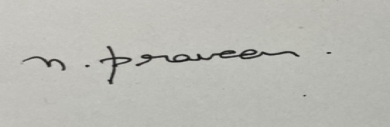

**Signature of the Student**

**Name: V Ratna Praveen Nandula**

**Date: 15/03/2022**

**Place: Bengaluru**



**Signature of the Supervisor**

**Name: Chella Pandian**

**Date: 15/03/2022**

**Place: Copenhagen, Denmark**

**Contents**

Abstract 3

1. Introduction 8

2. Objectives 8

3. Steps Involved in binary classification. 9

3.1. Data Extraction, Import Data, Check data integrity. 9

3.2. Apply Basic Visualization 9

3.3. Text Pre-processing 9

3.3.1. Apply Lower Case 10

3.3.2. Define a function to perform basic steps like expanding contractions & Removing Accented Characters. (Using NFKD, NFKL, NFD). 10

3.3.3. Translate text to English 10

3.3.4. Spell Correction 10

3.3.5. Check Integrity of Data (Check Junk Data) 10

3.3.6. Word Count. 10

3.3.6.1. Check if words in a review are fewer and drop them. 10

3.3.7. Convert Dictionary to DF 10

3.3.8. Remove first quartile values. (Less number of words will not give a good prediction). 11

3.3.9. Stop words, stemming, tokenizing 11

3.3.9.1. Using spacy 11

3.3.9.2. Add customized stop words 11

3.3.9.3. Use NLTK’s stemmer 11

3.3.9.4. Tokenize 11

3.3.9.5. Custom Stop words Removal 11

3.3.9.5.1. nlp.vocab[w].is_stop=False 11

3.3.9.6. Stemming 12

3.3.10. Split the text into four columns (Data Sets) 12

3.3.11. Remove stop words from clean text datasets and run models. 12

3.3.12. Plot the Text again a. Plot without stop words b. Plot with stop words c. Plot frequency (Word Cloud) 12

3.3.13. TF-IDF 12

3.4. Model Building 12

3.4.1. Clustering (K-Means) 12

3.4.2. SVD using sci-kit learn 13

3.4.3. ML Models 13

3.4.3.1. Logistic Regression 13

3.4.3.2. Linear SVC 13

3.4.3.3. Random Forest 13

3.4.3.4. XG Boost 14

3.4.4. Deep Learning Models 14

3.4.4.1. LSTM 14

3.4.4.2. CNN + RNN (LSTM) 14

4. Steps involved in Multi-Class Classification using BERT 15

4.1. Introduction 15

4.2. EDA & Pre Processing 16

4.3. Training/Validation Split 16

4.4. Tokenization and Encoding of the Data 16

4.5. Setup BERT Pretrained Model 16

4.6. Create Data Loaders 17

4.7. Setup Optimizer and Scheduler 17

4.8. Defining Performance Metrics 17

4.9. Create Training Loop 17

5. Sentiment Analysis – Comparison of various approaches 18

6. Conclusion 19

7. Recommendations / Improvements 19

8. References 20

9. Appendix 21

9.1. Data Extraction, Import Data, Check data integrity. 21

9.2 Apply Basic Visualization 28

9.3 Text Pre-processing 35

9.4 Model Building 47

9.4.1 Clustering 47

9.4.1.1 K-Means Clustering 47

9.4.2 Truncated SVD (Latent Semantic Analysis - LSA) using Sci-kit learn. 48

9.4.3 ML Models: 49

9.4.3.1 Logistic Regression 49

9.4.3.2 Linear SVC 53

9.4.3.3 Random Forest Classifier 56

9.4.3.4 XGBoost 56

9.4.4 Building Deep Learning Models: 57

9.4.4.1 LSTM Model 57

9.4.4.2 LSTM + CNN 60

9.5 BERT Model 61

9.5.1 EDA & Pre Processing 61

9.5.2 Training/Validation Split 63

9.5.3 Tokenization and Encoding of the Data 64

9.5.4 Setup BERT Pretrained Model 64

9.5.5 Create Data Loaders 65

9.5.6 Setup Optimizer and Scheduler 65

9.5.7 Defining Performance Metrics 66

9.5.8 Create Training Loop 66

10 Particulars of the Supervisor and Examiner 68

# Introduction

This project aims to build a Machine Learning or Deep Learning Model using Natural Language Processing (NLP) to help organisations create portals, giving them polarity or reputation. For this purpose, two approaches are taken. In the first approach, binary classification is done using various machine learning and deep learning models. In the second approach, a multi-class classification is done using the BERT algorithm. In binary type, the data is extracted through the rotten tomatoes website using pandas, and in multi-class classification, data is downloaded online. In both cases, Exploratory Data Analysis, Data cleaning, and tokenization are done.

Further, various models are applied to the cleaned data to conclude which model best suits for predicting the sentiment of a given text or comment. Doing so will help find reputation and take necessary steps by the organizations to improve their customer experience, increasing sales and revenue.

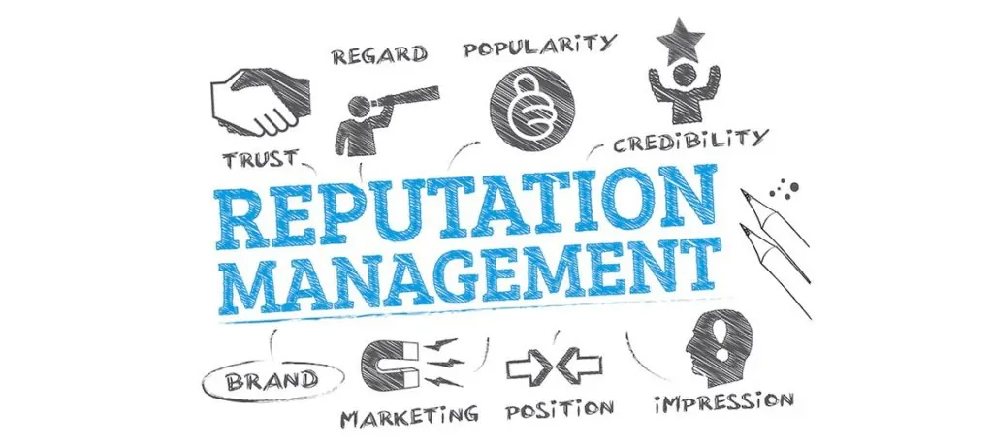

# Objectives

The objectives of this project are as follows:

* 1. Extract data from the web using data mining or APIs that various online platforms provide.
  2. Understand the text and convert it into a machine-understandable format by using NLP.
  3. Convert the data into meaningful insights or information that gives companies or individuals the polarity of their brand or product.
  4. Validation of the prototype is the critical component of our project. The research plan for the current project is to do the user evaluation of the current prototype.

# Steps Involved in binary classification.

# Data Extraction, Import Data, Check data integrity.

The purpose of this step is to first extract data from the rotten tomatoes website using a python program, then import the data into our python program using the pandas library. Then check the integrity of the data so that there are no missing values or data clutter. In this step, various libraries are used like numpy, pandas, data visualization library matplotlib, and DateTime library to convert date formats to a usable format.

By applying this step, we are able to find out that:

* The sentiment data is unbalanced. Logistic regression gave 59% accuracy.
* So, selecting smart data (Balanced data) because SMOTE will not yield good results with Text Data.

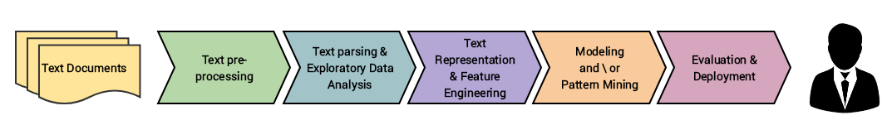

*Fig 3.1.1 Bird’s View of the Text Analytics Activity*

# Apply Basic Visualization

Applying visualizations will enable us to discover insights that cannot be seen using raw data. Following are the insights found by using visualization on various data features:

* Super Reviewer has two categories and only very few data points in one of them, so it might not be a good predictor
* Many reviews are given on Monday and the next highest on Sunday.
  + So, movie viewing could be high on Saturday and Sunday, and people might have written reviews on Sunday and Monday.
  + So, movie producers could get more profits if the movie is cast in more theatres on weekends.
  + Five ratings are more than any other rating; 2nd best rating is 3. So many viewers are satisfied with the movie.

# Text Pre-processing

This step is used to prepare the data to be read by various models. In this step, we will clean data, so the text makes sense. So, spell check, checking junk data, and finding word count are applied here.

# Apply Lower Case

Convert all the data to lower case to be easy for the models to read. This will also avoid prioritizing and duplicating the words based on the case.

# Define a function to perform basic steps like expanding contractions & Removing Accented Characters. (Using NFKD, NFKL, NFD).

In this step, we remove accented characters so that there won’t be any clutter in the data.

# Translate text to English

In this step, we use text blob library, which will convert language from any other language to English, so that all the data is consistent in one language that we are working on, which is English.

# Spell Correction

Using text blobs correct function, we correct the spelling of data. This again helps avoid duplication of data and avoid words that can be outliers. Further, performing this step also helps in achieving higher accuracy of prediction.

# Check Integrity of Data (Check Junk Data)

In this step, we check if the data we have cleaned so far matches the original data or not.

# Word Count.

# Check if words in a review are fewer and drop them.

In this step, we analyze the data to find outliers. Identify outliers and remove them. Text with too many words or text with far lesser words than the average would decrease the value of the correlation coefficient, thereby weakening the regression relationship. By performing this step, we mitigate the risk of having lower accuracy in the prediction.

# Convert Dictionary to DF

For convenience, all the cleaning so far has been done in the dictionary. This step converts the data to dictionary format to prepare it for further actions.

# Remove first quartile values. (Less number of words will not give a good prediction).

In this step, we check if removing the first quartile of data would give a better prediction, as it sometimes helps to have data with more words than lesser words. However, the model didn’t provide good results when data was removed. So, I retained all the data for further processing.

# Stop words, stemming, tokenizing.

Stop words: In this step, we try to eliminate the most commonly used words like “a”, “the”, “are”, “is”, etc. the purpose of performing this step is to eliminate bias in the data, if any.

# Using spacy

Spacy is a library that contains English language stop words. We used this library to import stop words and remove them if necessary.

# Add customized stop words.

This step adds the custom stop words library to the program and identifies the top 10 stop words. After that, we try to remove the stop words.

# Use NLTK’s stemmer

This step helps eliminate words that have suffixes or prefixes. The word will be attached to the root word, also called the lemma.

# Tokenize

Tokenization will let us break raw text into small chunks of words and sentences called tokens. These tokens will help us understand context or develop a model for the NLP.

# Custom Stop words Removal

# nlp.vocab[w].is_stop=False

Using the above-mentioned function, the stop words task is performed. Following are the results that are produced after completing this step:

* Adding custom stop words gave terrible results. Hence removed the custom stop words.
* Defined custom functions for Tokenization, stemming, and lemmatization. Then cleaned the data using the custom functions.
* Further, plotted most frequently used words before and after stop word removal.

# Stemming

In this step, the stemming task is performed using NLTK’s Stemmer function.

# Split the text into four columns (Data Sets)

In this step, the dataset is split into four so that each dataset contains stemmed, lemmatized data for each training and test data.

# Remove stop words from clean text datasets and run models.

In this step, stop words are removed, and the models are run to check accuracy. This step is eliminated because the accuracy was not better than the data with stop words.

# Plot the Text again a. Plot without stop words b. Plot with stop words c. Plot frequency (Word Cloud)

Plotting frequency plot gives us a visual interpretation of the frequently used words in the text. Following are some observations:

* Most occurring words present in both graphs are pretty different.
* Most occurring words present in graph 1 make more sense.

# TF-IDF

Further, applied TF-IDF Vectorization on test data, unseen data, and lemmatized data also, and observed that the TF-IDF matrix on the lemmatized text, which is not cleaned for stop words, gave better accuracy and predictions than stemmed data, stemmed data with stop words removed, lemmatized data with stop words removed.

TF-IDF combines Term Frequency and Document Frequency. TF gives how vital is a specific term in the document, while document frequency gives the number of records in which a particular term is available. And further, it converts text data into a machine-readable vector format.

# Model Building

In model building, we predict outcomes and classify data into an appropriate class.

# Clustering (K-Means)

A cluster is a collection of similar data points aggregated together. And k refers to the number of centroids in the dataset. Using k-means, we can classify data into the binary classes that we predict.

# SVD using sci-kit learn

Truncated SVD performs linear dimensionality reduction in the form of truncated singular value decomposition. This works especially with sparse matrices efficiently. As the text data has a lot of vectors, truncated SVD would perform better on the data.

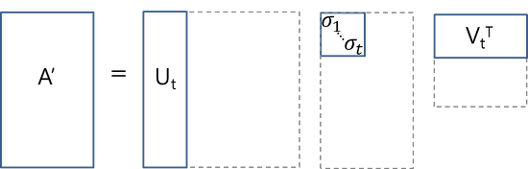

*Fig 3.4.2.1 - Fig showing Truncated SVD*

# ML Models

# Logistic Regression

Logistic regression is used to predict categorical dependent variables using given set of independent variables.

Predictions are better on the hyper parameter value c=0.5. Train accuracy = 0.89, Test Accuracy = 0.80, Train F1 = 0.89, Test F1 = 0.80

# Linear SVC

Linear regression is the supervised Machine Learning Model, in which the model finds the best fit line between the independent variable and dependent variable. Means, it finds the linear relationship between the variables.

Predictions are better on the hyper parameter value c=1. Train Accuracy = 0.98, Test Accuracy = 0.79, Train F1 = 0.98, Test F1 = 0.79. Higher difference between train and test accuracy suggests it might not be a better model for prediction.

# Random Forest

Random forest aggregates all decision trees to limit overfitting and error due to bias. So it yields valuable results.

Predictions for the model are Train Accuracy = 0.99, Test Accuracy = 0.8, Train F1 = 0.99, Test F1 = 0.80. Higher train accuracy suggests the model is overfitting, and is not a better predictor.

# XG Boost

XGBoost is an open-source implementation of gradient boosted tree algorithm. It is a supervised learning algorithm that tries to accurately predict a target variable by combining estimates of a set of simpler, weaker models.

Predictions for the model are Train Accuracy = 0.91, Test Accuracy = 0.80, Train F1 = 0.91, Test F1 = 0.8. We would compare with other models to determine which model performs better on the unseen data.

# Deep Learning Models

# LSTM

Long Short-Term Memory (LSTM) is a deep learning model with feed back connections, unlike feedforward neural networks. It is highly used in handwriting recognition, speech recognition, and anomaly detection in network traffic. Hence we have used LSTM in our model.

LSTM is imported from the TensorFlow library. Various hyperparameters like Max_NB_Words, MAX_SEQUENCE_LENGTH, EMBEDDING_DIM, and dropout are used.

Further, three epochs and a batch size of 128 are taken to run the model on a local machine.

Finally, the model gave a loss of 0.47 and accuracy of 0.797

# CNN + RNN (LSTM)

Convolutional Neural Networks are a class of Artificial Neural Networks most commonly used to analyze visual data. However, CNN combined with LSTM could predict better in the case of text data.

For this purpose, a model is created with one embedding layer, one dropout layer, one convolutional layer, one max-pooling layer, one LSTM layer, one dense layer, and finally, one output layer, which uses adam as an optimizer, and loss as binary cross-entropy.

The results are a loss of 0.475 and an accuracy of 0.818

**The outcome of programming:**

In ML, Linear SVC Performed well with various hyperparameters. In Deep Learning Models, CNN + LSTM performed well.

# Steps involved in Multi-Class Classification using BERT

This task aims to find sentiment for six output levels (multi-class classification). BERT helps build this multi-class classification, and the most significant advantage of BERT over other algorithms is that BERT retains the context of the text, which gives better predictions.

# Introduction

Bidirectional Encoder Representations from Transformers (BERT) is an algorithm developed by researchers at Google AI Language. BERT is different from other Deep Learning algorithms by applying bidirectional training of transformers and is a very popular attention model in language modeling. By being bidirectional, the main advantage of BERT is that it retains context, in contrast to single directional language models. By keeping context, BERT will be able to predict better outcomes.

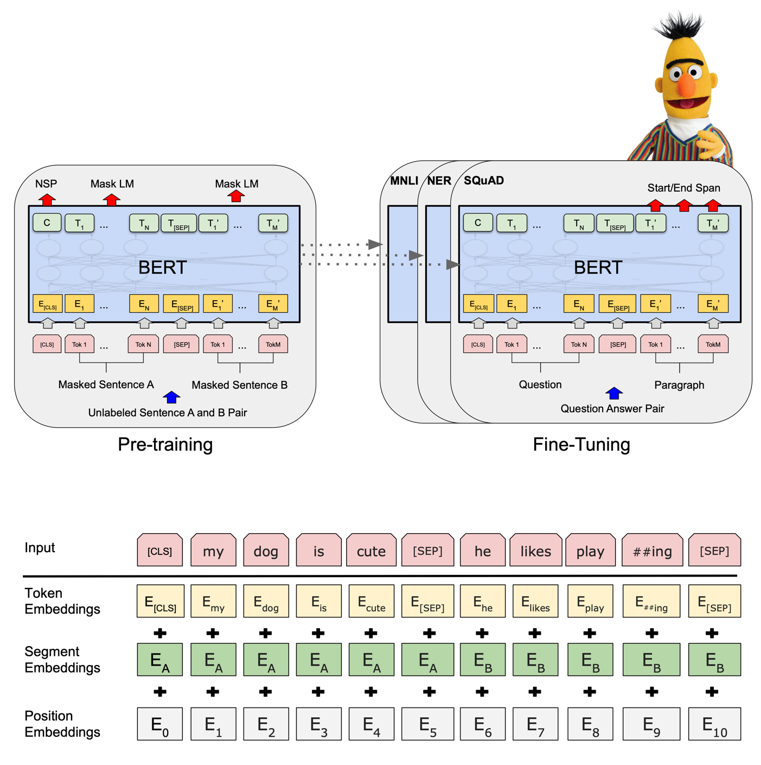

# EDA & Pre Processing

In this step, we perform Exploratory Data Analysis by importing data from the CSV file that we have downloaded from the SMILE Twitter database. We perform various operations to set index for id. Further analysis identifies the outliers and features with less data points. By doing so, Some classes that have a mixture of polarity and those that don’t have any polarity (nocode) have been dropped to tackle the class imbalance problem.

Further, data is converted from a dictionary to a data frame. Now the data is ready for further training.

# Training/Validation Split

In this step, the data from the above step is converted into train and test data sets. The train data set will be used to train the model, and the test will be used to test the model's accuracy.

As the data has multiple levels, there are high chances that the train test split would create a class imbalance problem. To handle this, I have used Stratified Sampling. It is the process where entire data is divided into homogeneous groups, collectively exhaustive and mutually exclusive. Then sampling is applied to each group (Stratum). Doing so will improve the precision of the sample by reducing sampling error.

In the program, by performing stratified sampling, train-test data is split.

# Tokenization and Encoding of the Data

BERT tokenization is distinct from regular tokenization. It splits words either into complete forms like one word becomes one token, or into pieces of the word like one word will be broken into multiple tokens. By doing so, BERT can identify related words that usually share some or more of the same input tokens. These are then fed into the first layers of BERT.

Encoder block in BERT implements the bidirectional encoder representations from transformers network in its base size. There are multiple encoder cells in BERT, each of them reads input and the decoder cell outputs the result. BERT reads all input words simultaneously.

The input data, attention mask, and the labels of train and test data are then passed to the model.

# Setup BERT Pretrained Model

Pre Trained Bert model “BertForSequenceClassification” model is then imported from the transformers library.

# Create Data Loaders

Data Loader combines a dataset and a sampler, thereby providing an iterable over a given dataset. Then we use a random sampler on train data and a sequential sampler on the validation data, thereby creating data loaders for train and validation data sets.

# Setup Optimizer and Scheduler

In the next step, we use the AdamW optimizer algorithm to minimize the error function (loss function) and maximize the efficiency of production.

Then we use a scheduler to adjust the learning rate between epochs or iterations, as the training proceeds.

# Defining Performance Metrics

Then we set up our performance metrics like F1 Score. F1 score combines the precision and recall of a classifier into a single metric by taking the harmonic mean between them. This is particularly helpful in our model, as there is a class imbalance, and as F1 provides a harmonic mean, it performs better.

# Create Training Loop

Then, we set up the training loop by setting seed value 17 due to the unavailability of GPU in local. Further, a customized code is written to use only CPU if GPU is not available.

Then the model is trained using 3 epochs. As output, in 3rd epoch, training loss = 0.64, validation loss = 0.67, and F1 score = 0.75.

Finally, predictions are made on the validation (test) dataset.

**Conclusion to the BERT Model:**

BERT model has performed well in the class with more data. However, it is not so accurate with types with fewer data. Although the original data has more than five classes, we have dropped some to handle the class imbalance problem, as there are fewer data in those classes. So, finally, five classes are retained.

**Improvements:**

Due to hardware constraints, the model is trained on fewer data. The deep learning BERT model will perform better with a decent GPU, hardware, and more data.

# Sentiment Analysis – Comparison of various approaches

Any sentiment analysis aims to find a range between the positive and negative spectrum. The challenge with Sentiment Analysis is that humans express and interpret sentiment polarity and intensity differently. Further, words and sentences can have multiple meanings based on context, also known as polysemy. Keeping this in mind, here there is a review of three methodologies.

In this approach, we compare and contrast three models.

1. Naïve Bayes
2. Deep Learning LSTM
3. Pre-Trained Rule-Based VADER Model

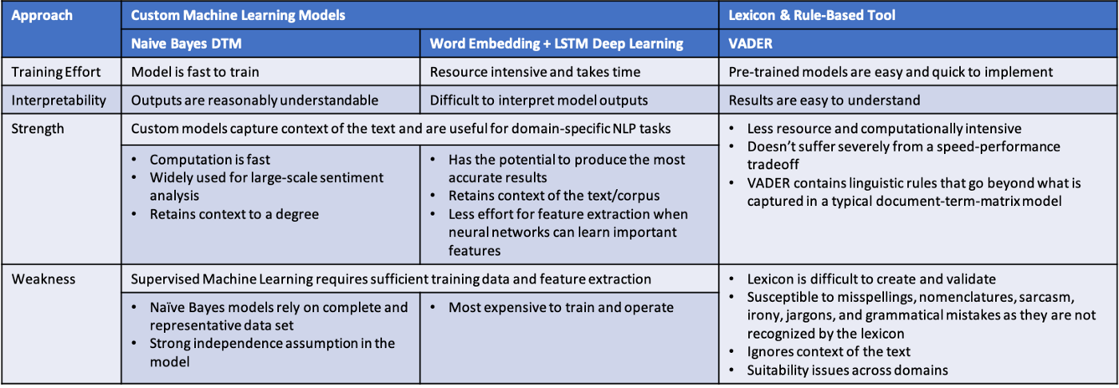

From the above comparison table, we can notice that each of the three approaches to Sentiment Analysis has its share of strengths and weaknesses. When it comes to choosing an appropriate strategy, the following things can be considered.

* The trade-off between accuracy and speed. If speed is the priority over accuracy, then Rule-Based solutions can be suitable.
* Naïve Bayes models can help implement the models faster when robust training data is available.
* If model interpretability is not a priority, then Deep Learning models are the best ones to use, which give higher accuracy with more data.

Although we have compared three different models, in recent days, running multiple models in parallel is also giving better results. One attempt in this project is using LSTM+CNN together to create a more accurate algorithm.

# Conclusion

In this project, the solution is attained in 2 phases.

In the first phase, I have used various Machine Learning and Deep Learning algorithms to check their performance in sentiment analysis. It has been shown that Deep learning models show higher accuracy. Multiple algorithms have performed well on data with about 12000 rows. The problem arises when the data contains ironic, sarcastic, and smiley content.

However, rich data cleaning methods like stemming, lemmatization, stop words, and spell check are performed on the data. With these models, higher accurate sentiment analysis can be achieved with more sentiment levels.

In the second phase, I applied the BERT (Bidirectional Encoder Representations from Transformers) algorithm to multi-class classification data to accurately determine sentiment. While BERT helps attain the context of the data, it has not performed as well as the other Deep Learning models, as BERT is a data-hungry model and would perform well when the data is significant. Further, the BERT would perform better in an environment where a decent CPU, GPU, and memory are available, providing superior results to other machine learning and deep learning models.

Finally, based on the research, Reputation Manager (RepMan) will change the game for organizations and individuals by doing the following:

* Provides various insights on data using visualizations.
* Predicts sentiment using various machine learning and deep learning or a combination of both.
* Give recommendations based on the predicted outcome.

Further, enwrapping the models in UI design will create a production-ready interface. Organizations can use the application with ease to enhance brand image and increase revenues. This application – Reputation Manager (RepMan) also helps celebrities, whose identity plays a crucial role in their popularity, discover what people think of them and develop better reachability into the crowds and market.

# Recommendations / Improvements

Following improvements are recommended to the project.

1. Running the models on large datasets is more extensive than the ones used in this project. Make sure that BIAS is reduced in the data that we use further.
2. Using Transfer learning lets the models take advantage of already trained (pre-trained) models to solve similar problems.
3. Having a higher system configuration to train and run models gives better results.
4. Using cloud services, which provide reliable storage, connectivity, and various other advantages, saves cost and risk of running vast amounts of data on the local.
5. Creating a UI, which can encapsulate the built models, provides an easy-to-use interface to search for required comments and provide appealing visual outputs.

# References

1. For data extraction, training data: <https://www.rottentomatoes.com/m/the_lion_king_2019/reviews?type=user>
2. [*https://www.rottentomatoes.com/m/the_batman/reviews?type=user*](https://www.rottentomatoes.com/m/the_batman/reviews?type=user)
3. BERT Algorithm reference from: [*https://arxiv.org/abs/1810.04805*](https://arxiv.org/abs/1810.04805)
4. SMILE twitter data set: Wang, Bo; Tsakalidis, Adam; Liakata, Maria; Zubiaga, Arkaitz; Procter, Rob; Jensen, Eric (2016): SMILE Twitter Emotion dataset. figshare. Dataset*.*[*https://doi.org/10.6084/m9.figshare.3187909.v2*](https://doi.org/10.6084/m9.figshare.3187909.v2)
5. BERT sesame image reference from: [*https://characters.fandom.com/wiki/Bert_(Sesame_Street*](https://characters.fandom.com/wiki/Bert_(Sesame_Street)
6. Text Blob: [*https://pypi.org/project/textblob/*](https://pypi.org/project/textblob/)
7. Reputation Management:<https://www.gartner.com/en/marketing/glossary/reputation-management>
8. Reputation Management:<https://spotonwifi.com/6-keys-successful-corporate-reputation-management/>
9. Tokenization*:*[*https://towardsdatascience.com/tokenization-for-natural-language-processing-a179a891bad4#:~:text=Tokenization%20is%20breaking%20the%20raw,the%20sequence%20of%20the%20words*](https://towardsdatascience.com/tokenization-for-natural-language-processing-a179a891bad4#:~:text=Tokenization%20is%20breaking%20the%20raw,the%20sequence%20of%20the%20words)
10. Stemming: [*https://www.techtarget.com/searchenterpriseai/definition/stemming - :~:text=Stemming is the process of,natural language processing (NLP)*](https://www.techtarget.com/searchenterpriseai/definition/stemming#:~:text=Stemming%20is%20the%20process%20of,natural%20language%20processing%20(NLP))
11. TF-IDF: [*https://towardsdatascience.com/tf-idf-simplified-aba19d5f5530 - :~:text=Term frequency-inverse document frequency,specific term in a document*](https://towardsdatascience.com/tf-idf-simplified-aba19d5f5530#:~:text=Term%20frequency%2Dinverse%20document%20frequency,specific%20term%20in%20a%20document)
12. k-means: <https://towardsdatascience.com/understanding-k-means-clustering-in-machine-learning-6a6e67336aa1>
13. Truncated SVD using sci-kit: <https://scikit-learn.org/stable/modules/generated/sklearn.decomposition.TruncatedSVD.html>
14. Logistic Regression: <https://www.javatpoint.com/logistic-regression-in-machine-learning>
15. Linear Regression: <https://www.analyticsvidhya.com/blog/2021/05/all-you-need-to-know-about-your-first-machine-learning-model-linear-regression/>
16. Random Forest: <https://en.wikipedia.org/wiki/Random_forest>
17. XGBoost: <https://docs.aws.amazon.com/sagemaker/latest/dg/xgboost-HowItWorks.html>
18. LSTM: <https://en.wikipedia.org/wiki/Long_short-term_memory>
19. BERT: https://towardsdatascience.com/bert-explained-state-of-the-art-language-model-for-nlp-f8b21a9b6270
20. Stratified Sampling: <https://en.wikipedia.org/wiki/Stratified_sampling>
21. BERT Tokenization <https://towardsdatascience.com/how-to-build-a-wordpiece-tokenizer-for-bert-f505d97dddbb#:~:text=BERT%20uses%20what%20is%20called,have%20multiple%20forms%20of%20words>.
22. PyTorch - <https://pytorch.org/docs/stable/data.html>
23. Sentiment Analysis – comparison of various approaches: https://towardsdatascience.com/sentiment-analysis-comparing-3-common-approaches-naive-bayes-lstm-and-vader-ab561f834f89

# Appendix

# Data Extraction, Import Data, Check data integrity.

Data Extraction:

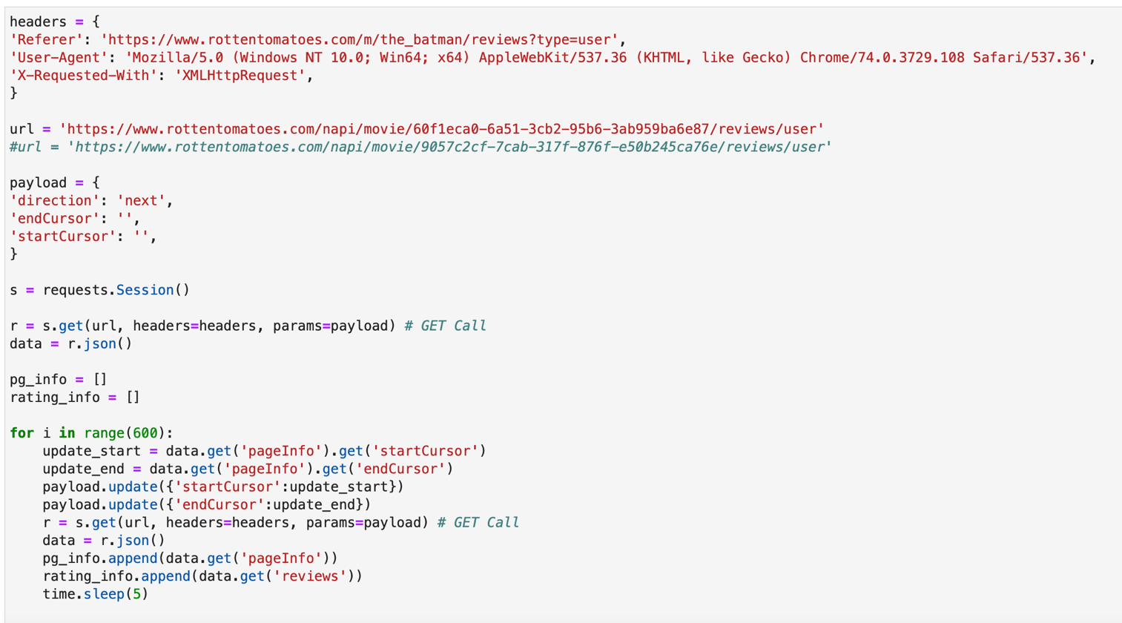

*Fig 9.1.1 Code chunk showing data extraction function in python*

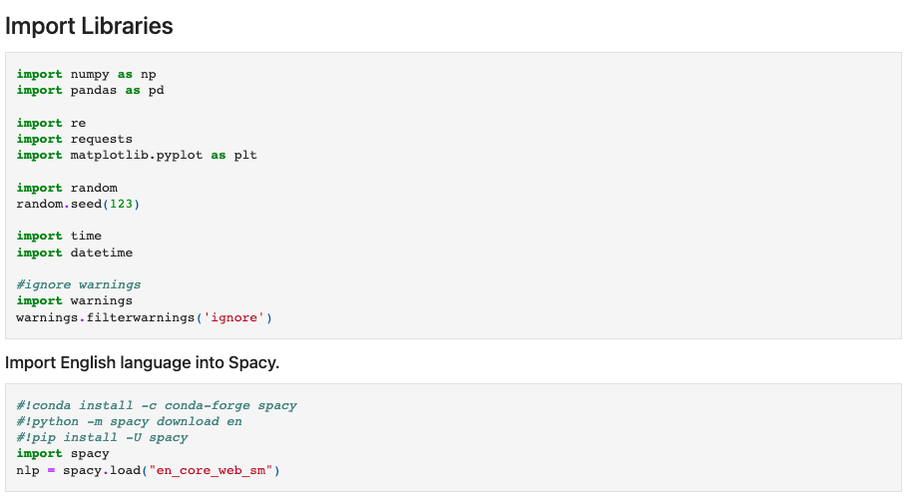

*Fig 9.1.2 Code chunk showing usage of various libraries in python*

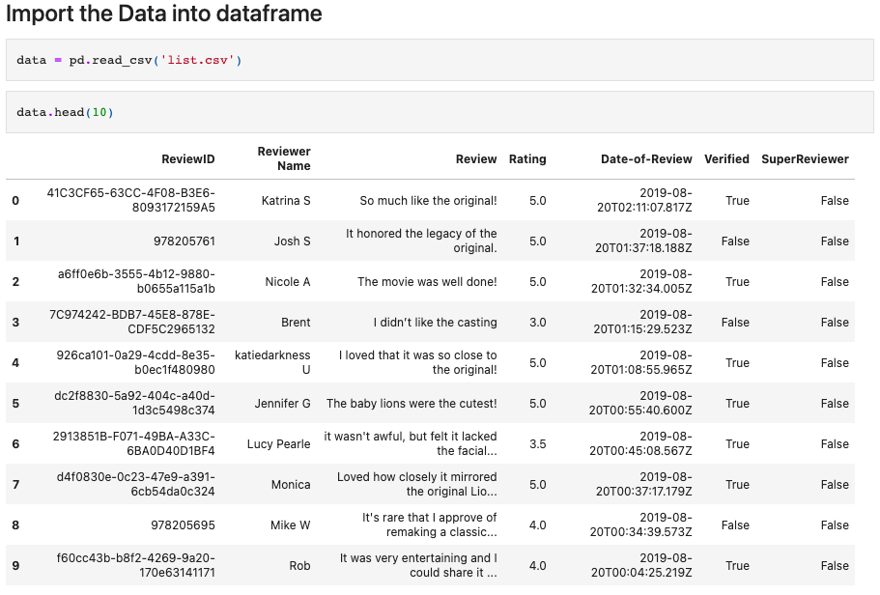

*Fig 9.1.3 Figure showing sample data that is imported from CSV file.*

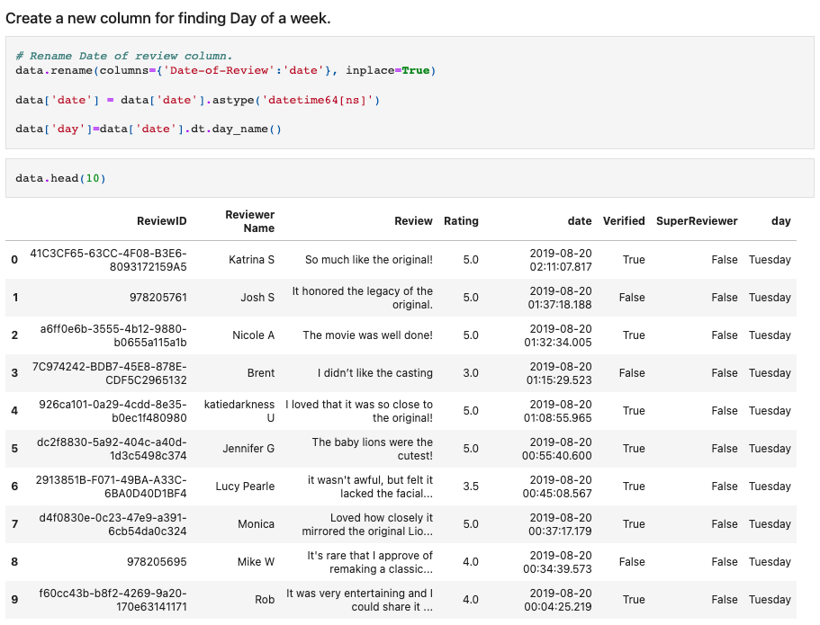

*Fig 9.1.4 Code chunk showing conversion of date to days of the week*

Importing Unseen Data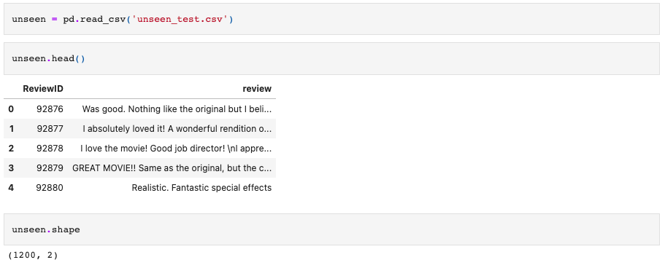

*Fig 9.1.5 Code chunk showing import of unseen data*

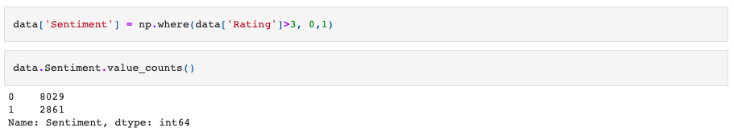

*Fig 9.1.6 Create a Sentiment column where 0 is a positive review, and 1 is a negative review.*

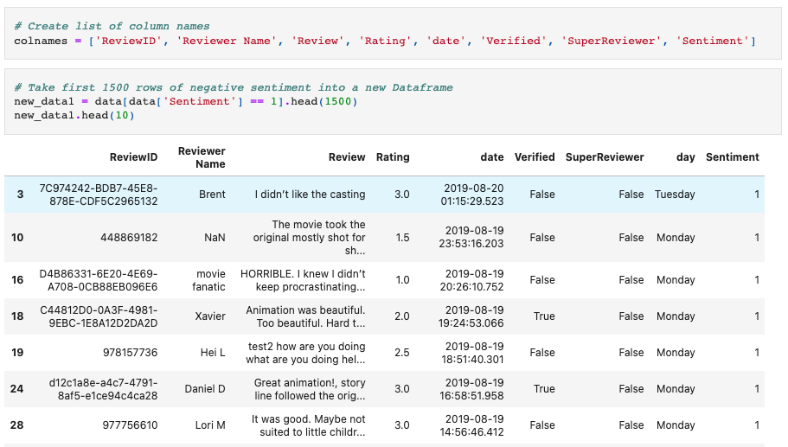

*Fig 9.1.7 Create a new data frame with the required data.*

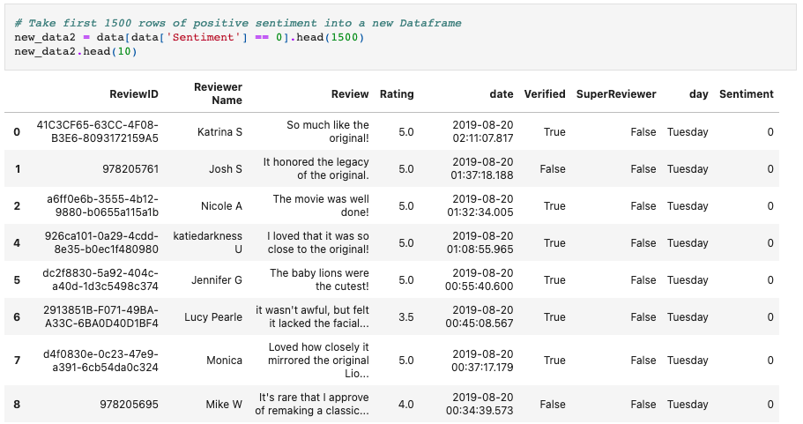

*Fig 9.1.8 Viewing of data that has sentiment as 0*

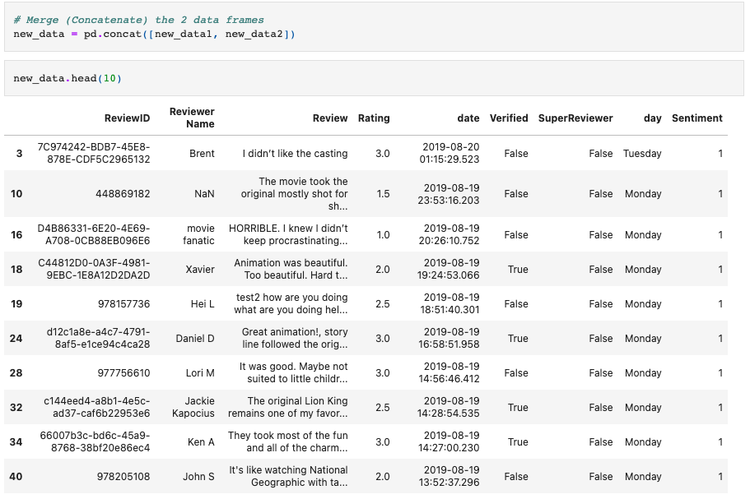

*Fig 9.1.9 Merge the 2 data frames.*

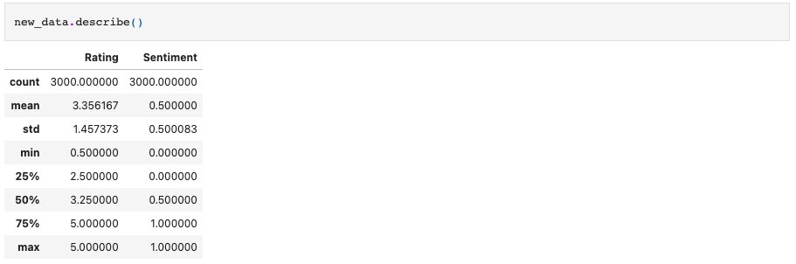

*Fig 9.1.10 What the data talks about (Measures of the information)*

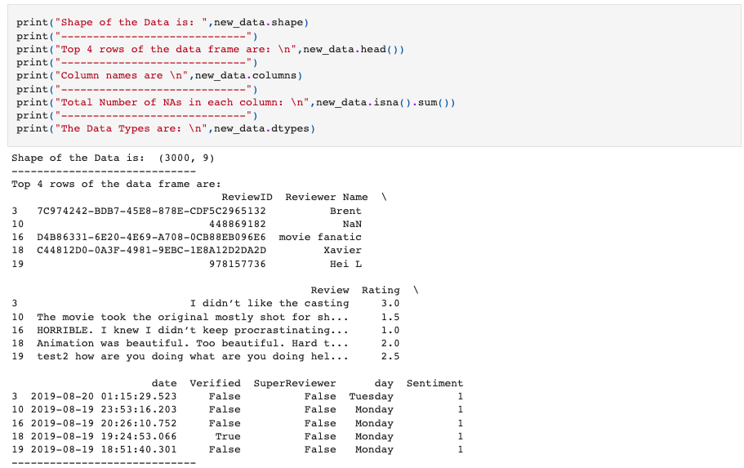

*Fig 9.1.11 Code chunk showing various data parameters to Know the data better*

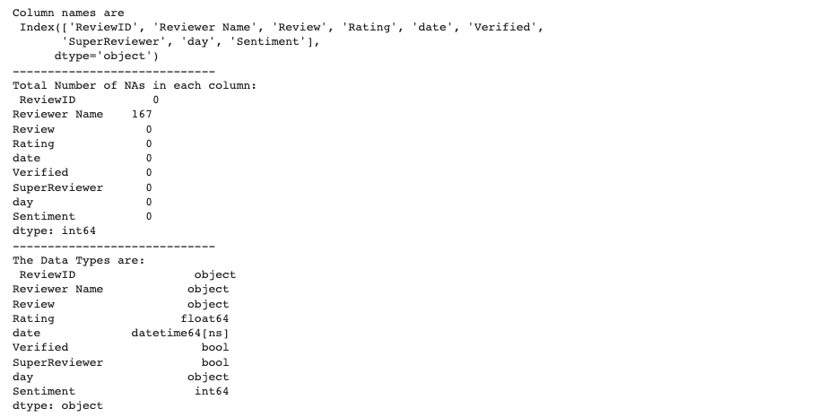

*Fig 9.1.12 (Continued from Fig 9.1.11) Code chunk showing various data parameters, to Know the data better*

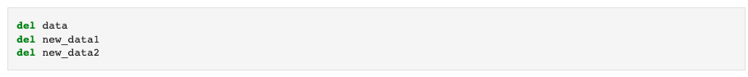

*Fig 9.1.13 Drop unnecessary data frames from memory*

## Apply Basic Visualization

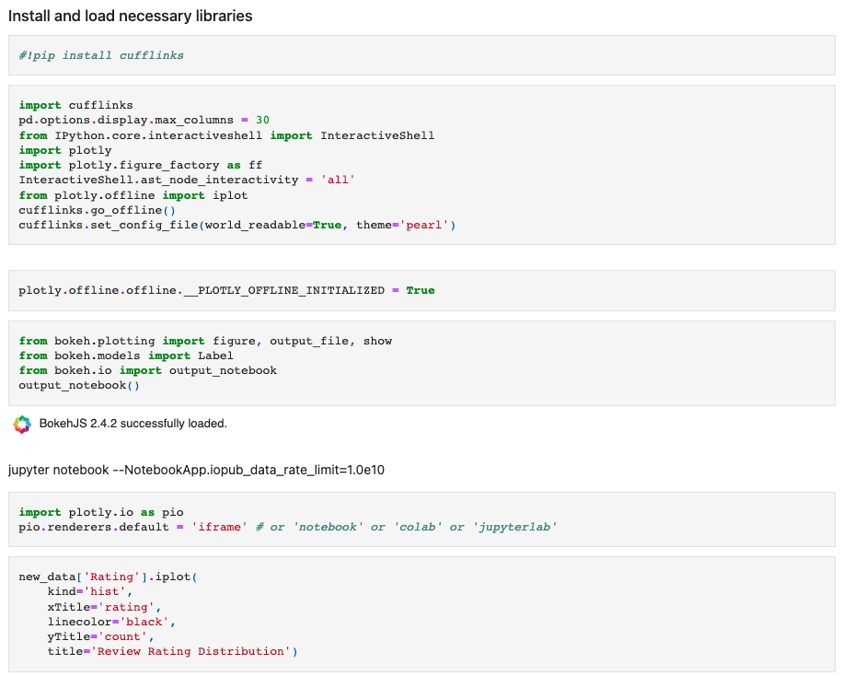

*Fig 9.2.1 Import of various data visualization libraries and defining a plot*

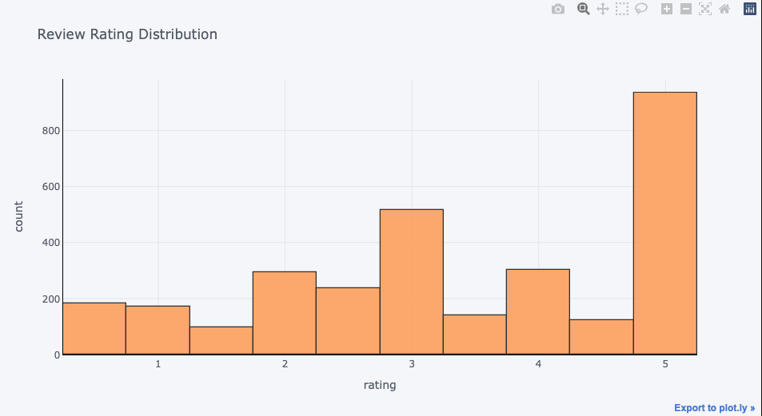

*Fig 9.2.2 Review rating distribution*

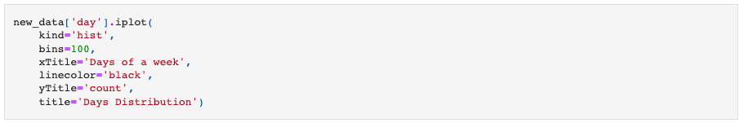

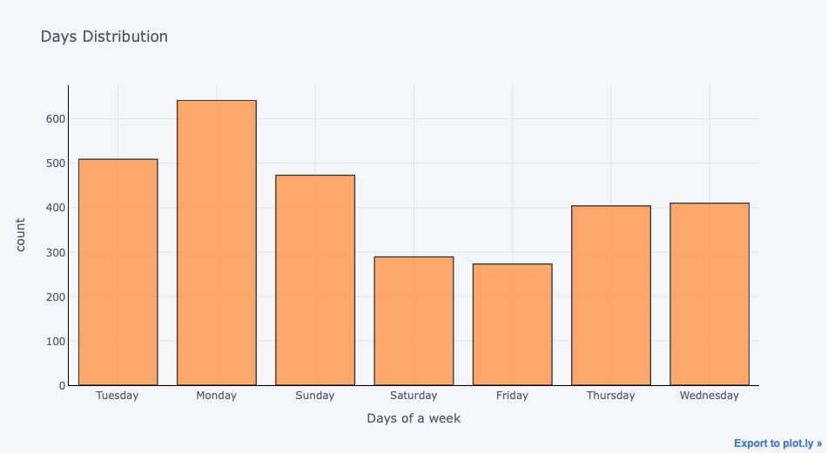

*Fig 9.2.3 Days of Week VS count of reviews*

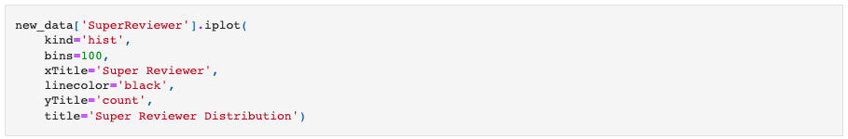

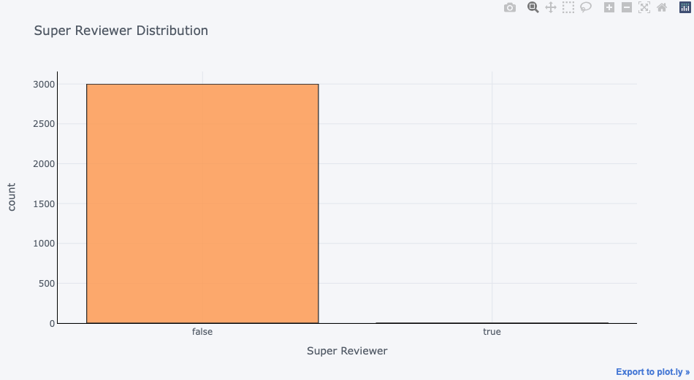

*Fig 9.2.4 Showing count of the super reviewer*

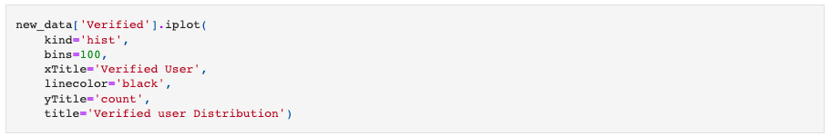

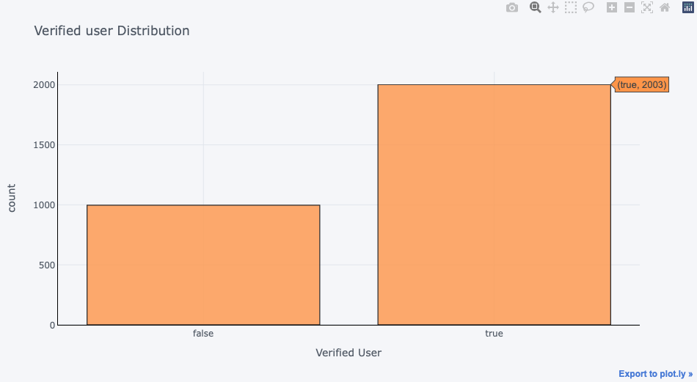

*Fig 9.2.5 Figure showing verified user distribution.*



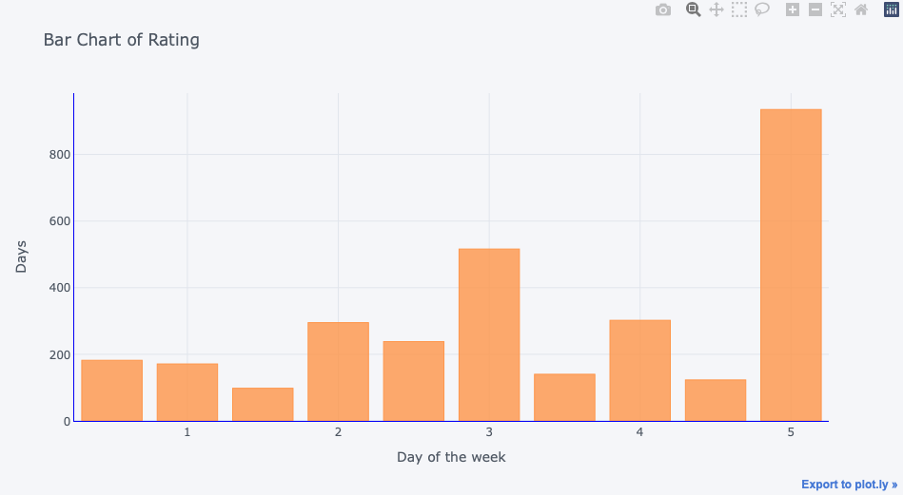

*Fig 9.2.6 Figure showing bar chart of ratings on day of the week vs. days*

Other Insights on Data

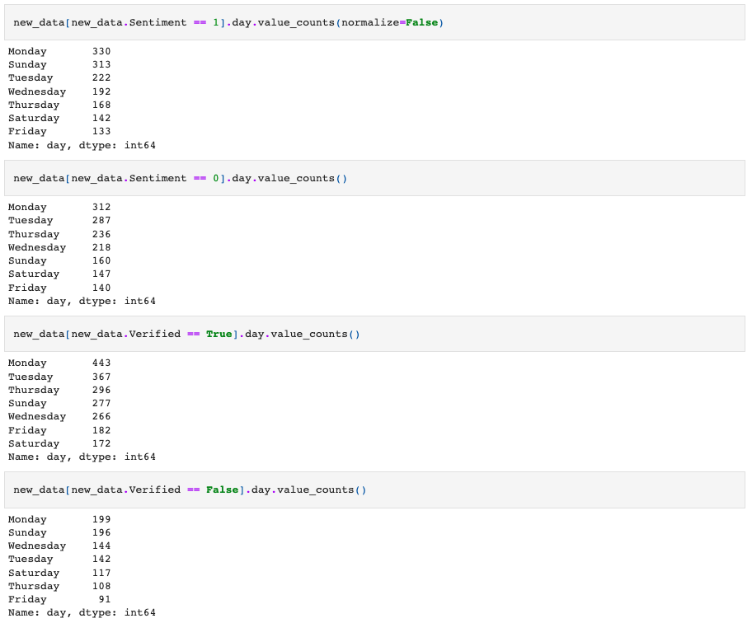

*Fig 9.2.7 Code chunk showing the output of various data insights.*

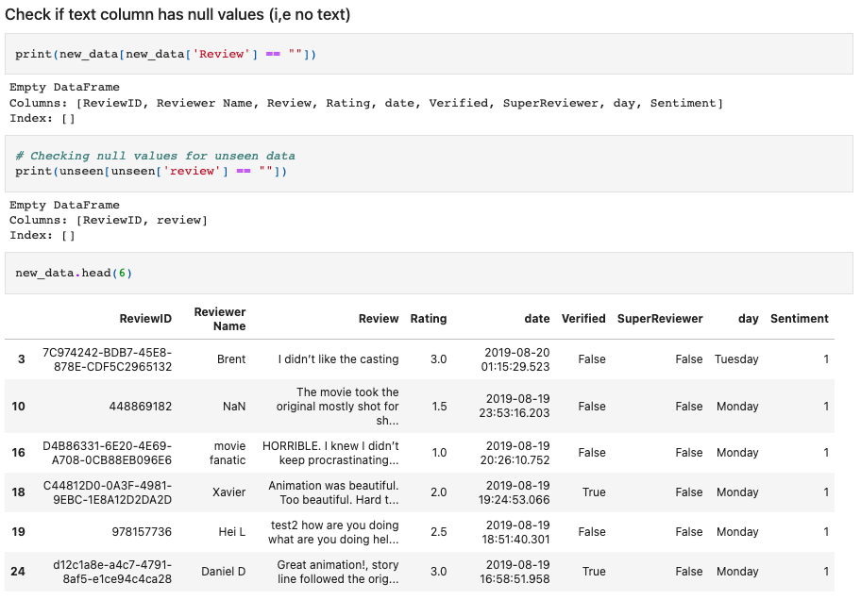

*Fig 9.2.8 Perform various EDA on data.*

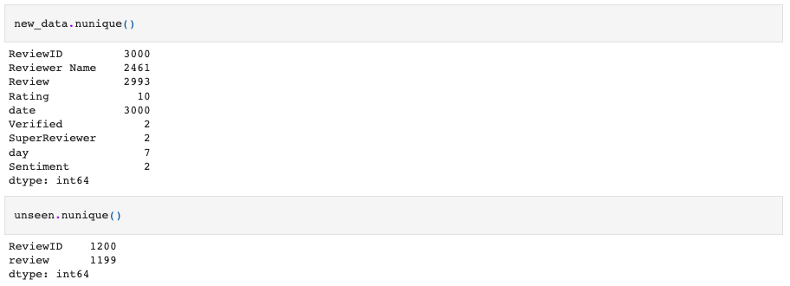

*Fig 9.2.9 EDA showing unique values in each column*

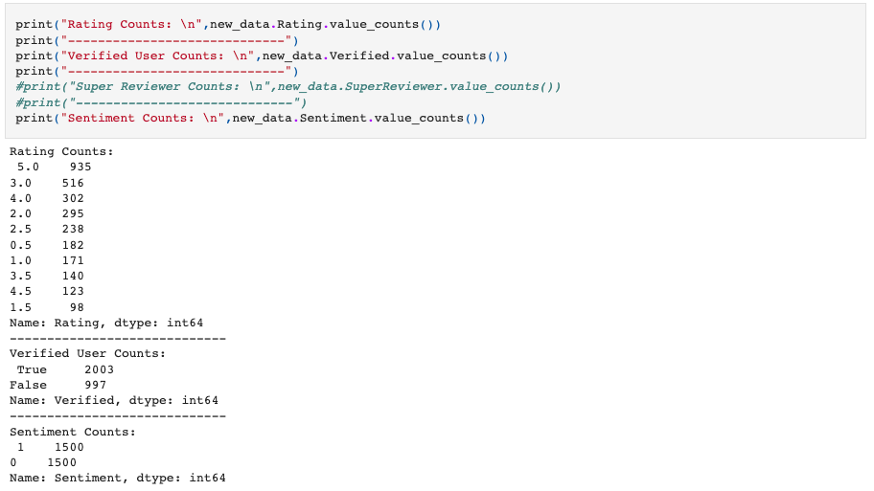

*Fig 9.2.10 EDA to find value counts on various columns of data*

## Text Pre-processing

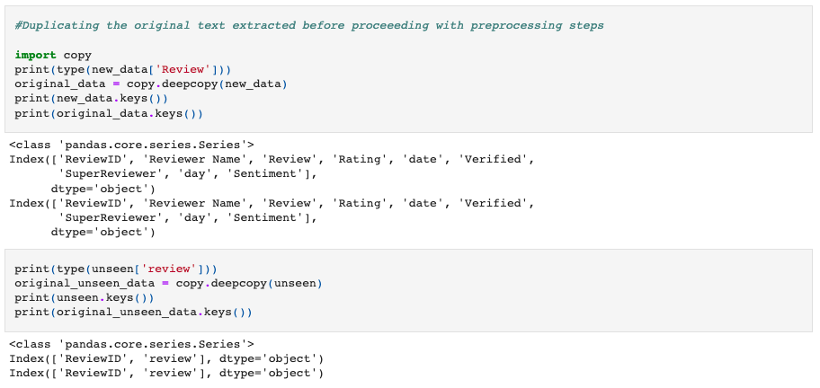

*Fig 9.3.1 Duplication of data for data preprocessing to preserve original data.*

**Basic Cleaning of Text:**

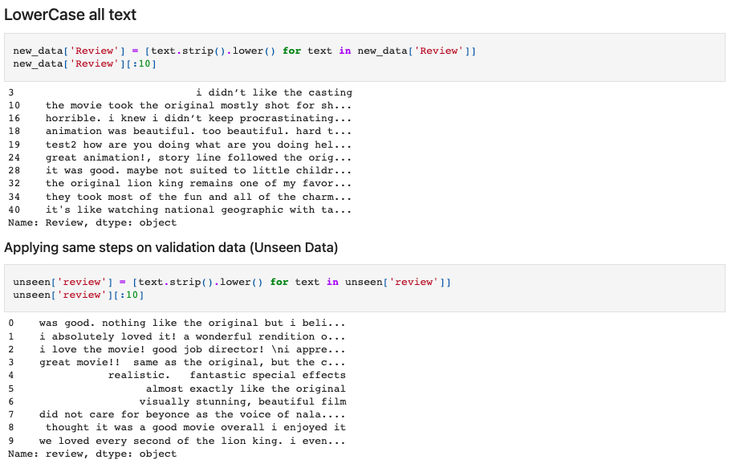

*Fig 9.3.2 Convert text to lower case.*

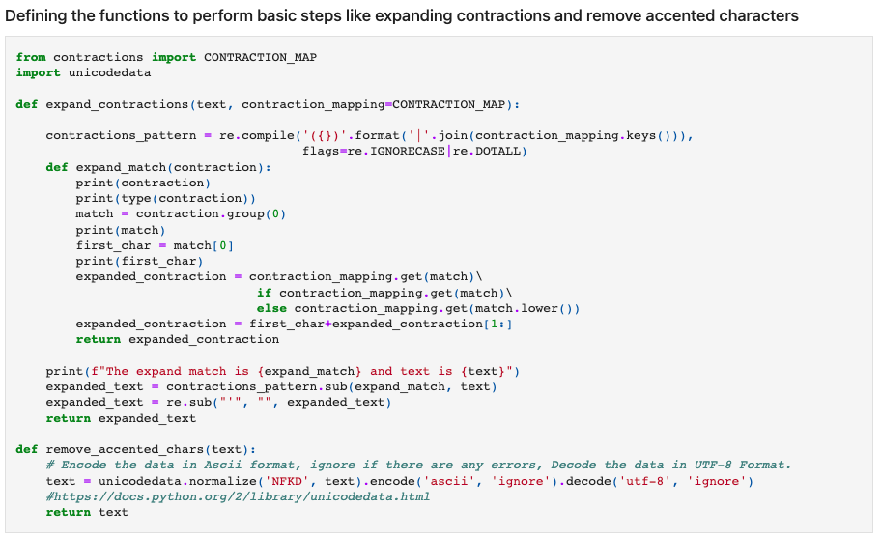

*Fig 9.3.3 Define functions to perform expanding contractions and remove accented characters.*

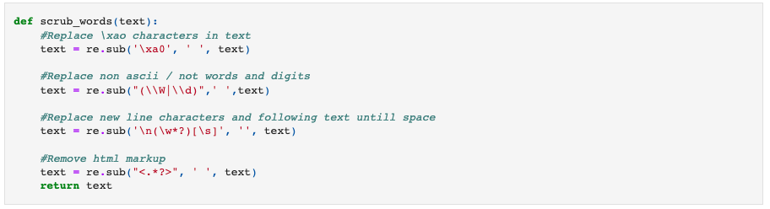

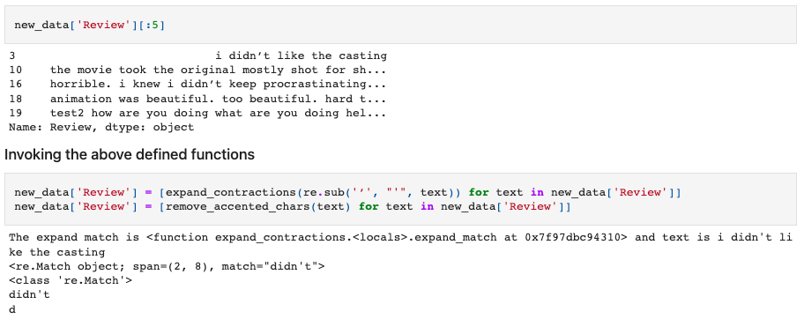

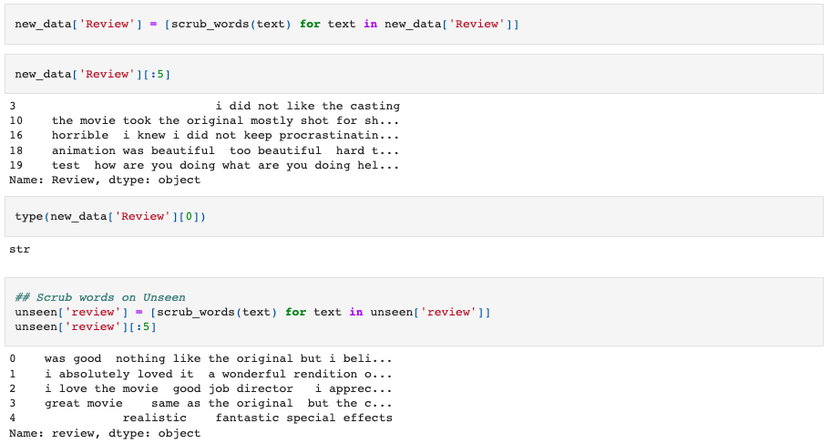

*Fig 9.3.4 Performing scrub words to perform various operations of cleaning data.*

**Spell Correction**

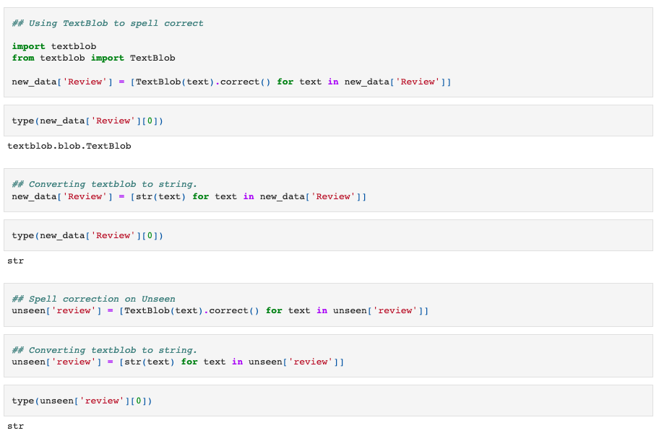

*Fig 9.3.5 Spell correction*

**Checking the Integrity of the data after initial pre-processing steps**

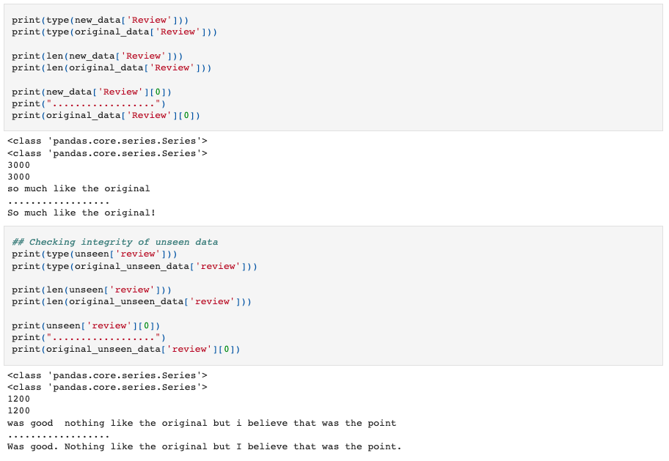

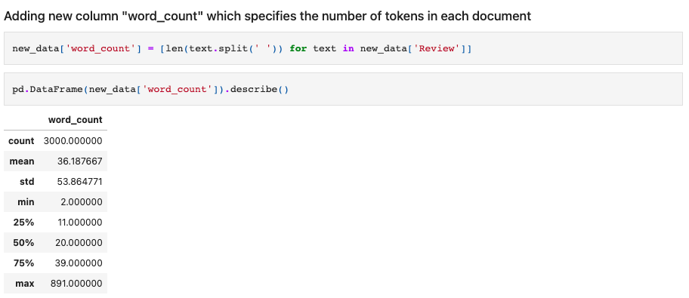

*Fig 9.3.6 Checking integrity of data.*

**Reviewing the word count distribution of the text**

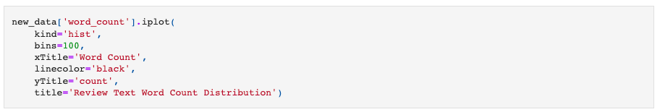

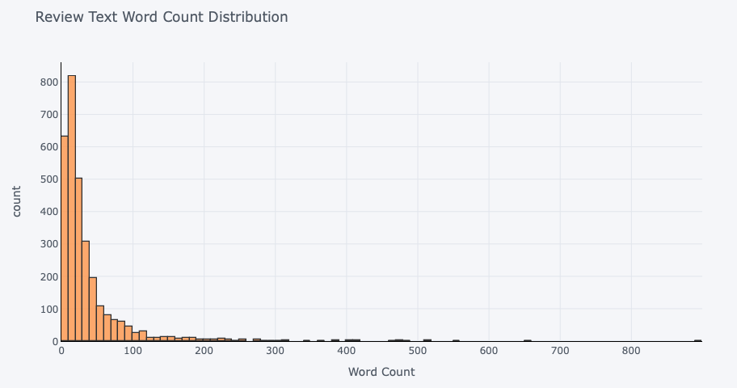

*Fig 9.3.7 Visualization of text word count distribution on text data.*

**Review text word count distribution**

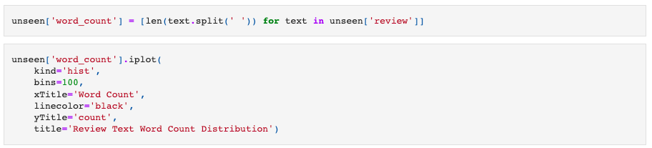

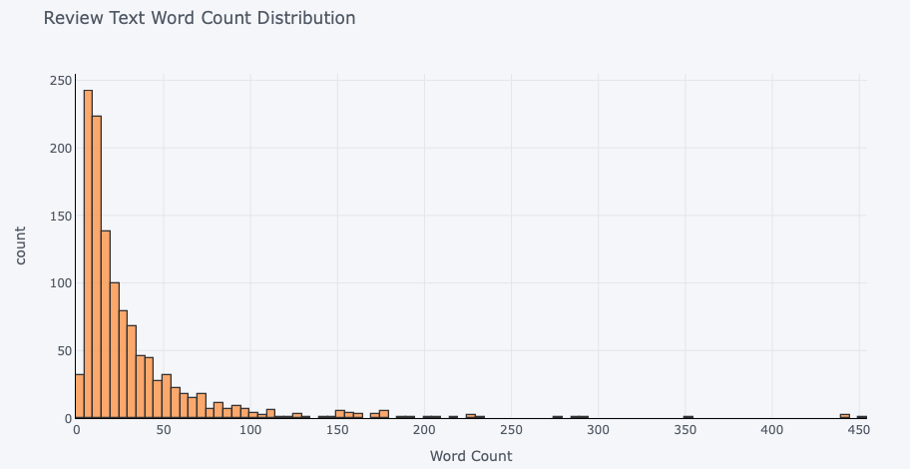

*Fig 9.3.8 Visualization of text word count distribution on unseen data.*

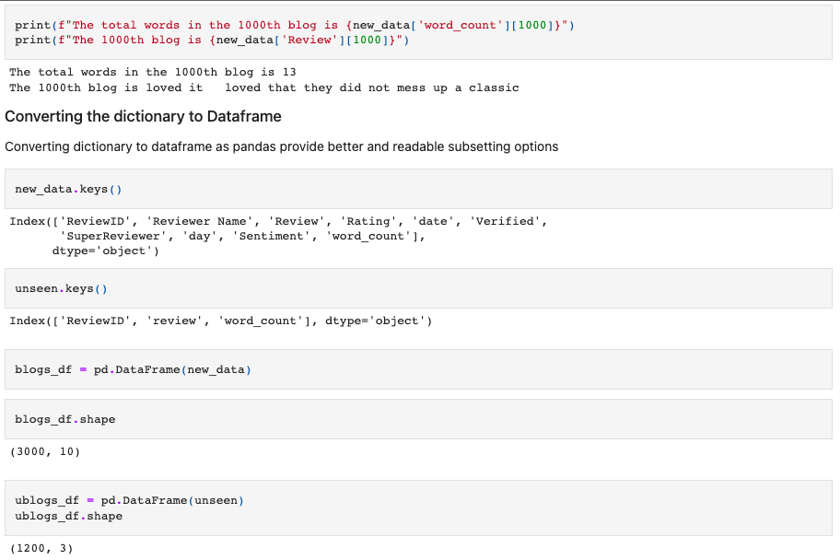

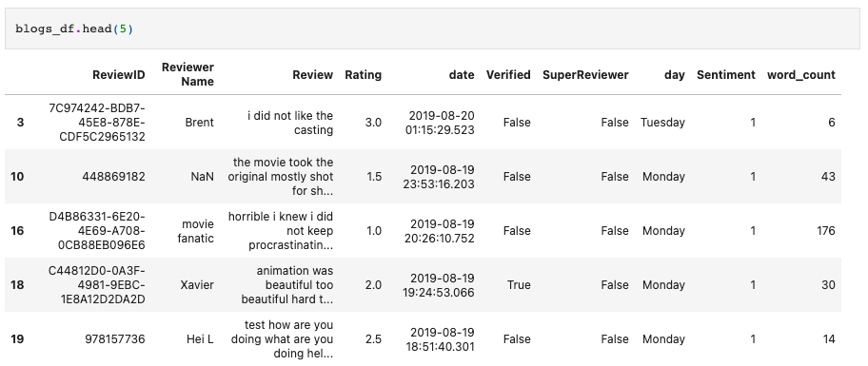

*Fig 9.3.9 Conversion the dictionary to a data frame, and then checking the data.*

* **Stopwords, Stemming, and tokenizing**

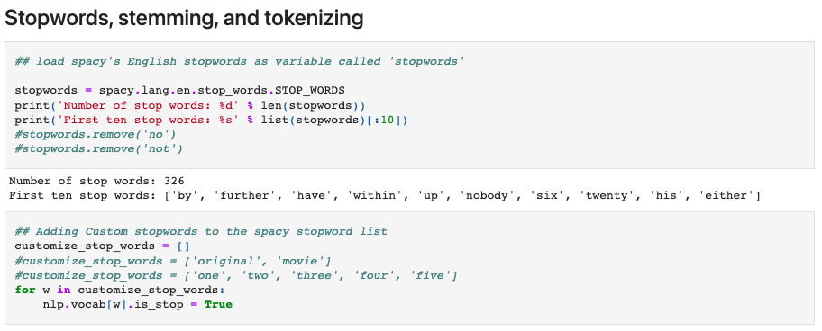

*Fig 9.3.10 Perform Stopwords, stemming, and tokenization.*

**Frequency Plot of words**

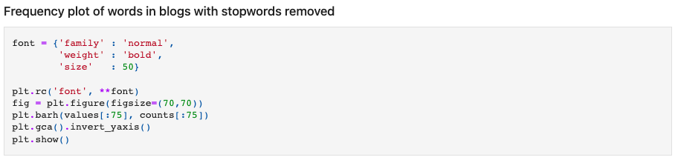

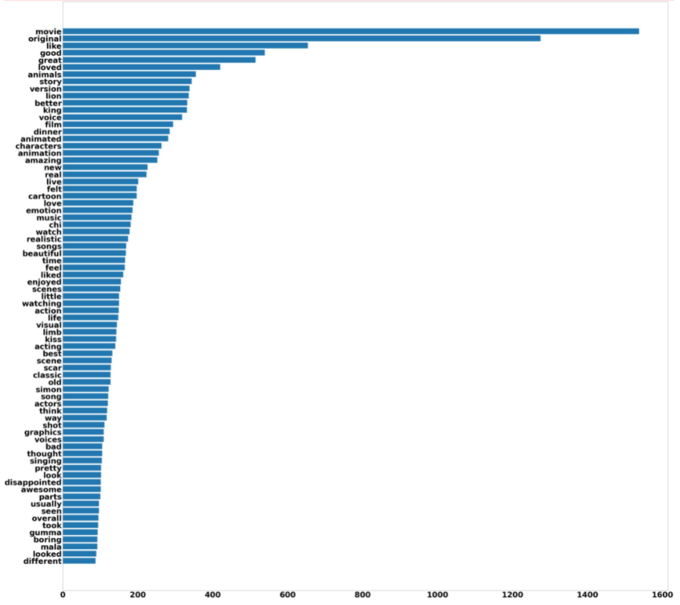

*Fig 9.3.11 Frequency plot of words*

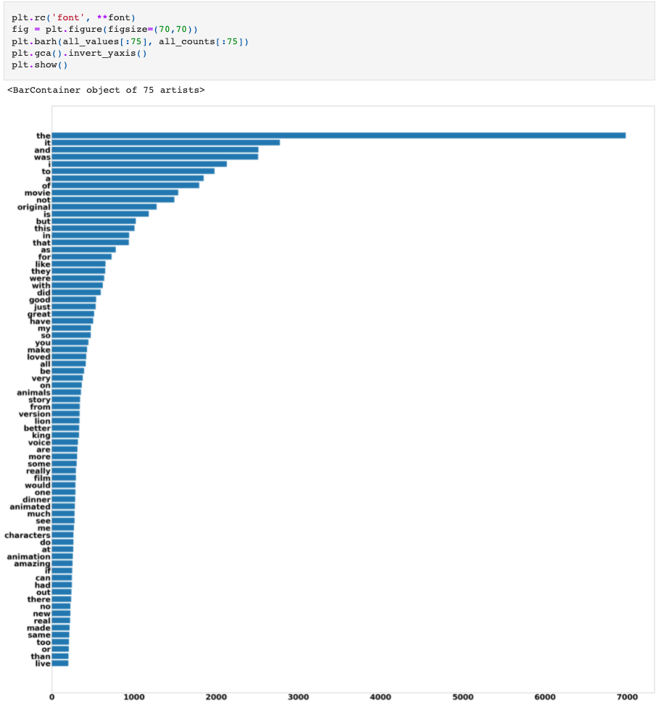

*Fig 9.3.12 Frequency plot of words in blogs with stop words retained:*

**Word Cloud of words that are frequently used:**

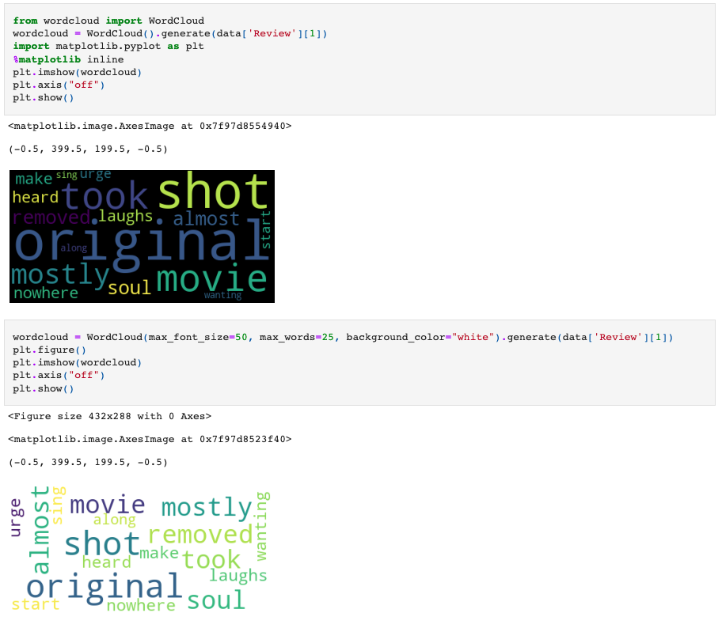

*Fig 9.3.13 Word cloud*

## Model Building

In model building, the train test split is done using a test size of 30% and a random state of 123.

Following are the results of various models.

## Clustering

### K-Means Clustering

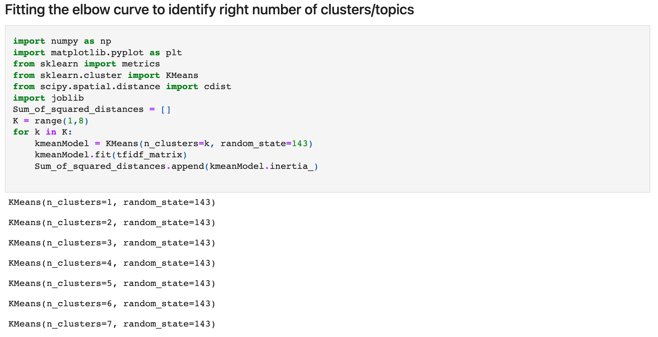

K-Means Clustering graph indicating that there are 2 clusters

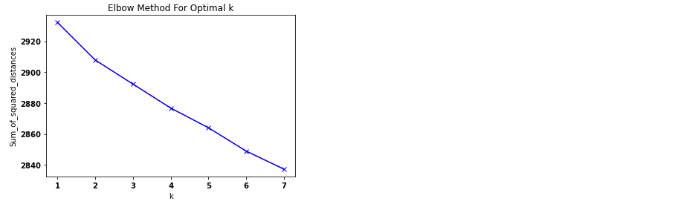

*Fig 9.4.1.1.1 K-Means Clustering Algorithm*

Top terms per cluster:

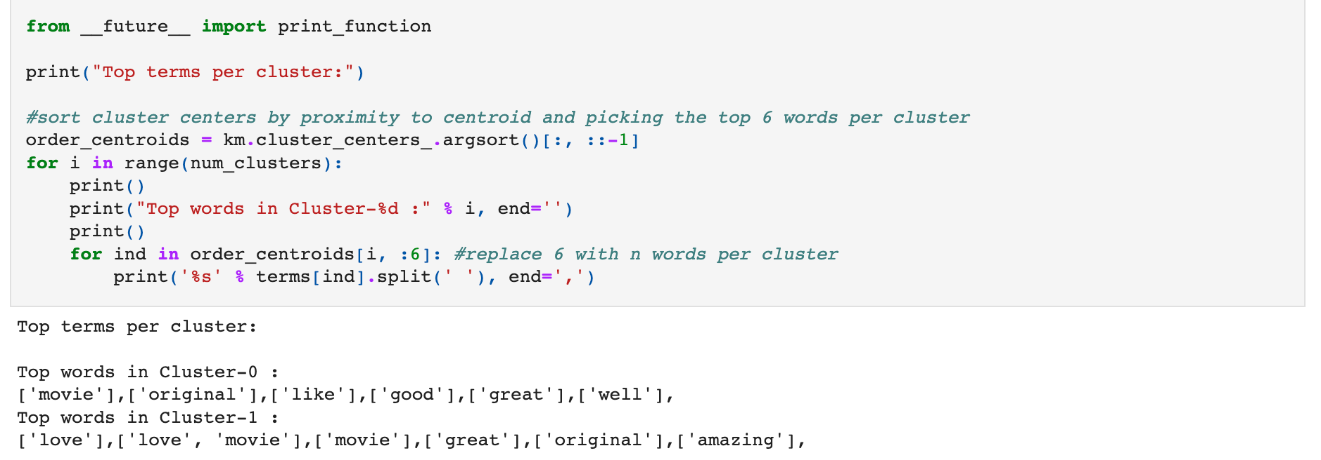

*Fig 9.4.1.1.12 Top terms per cluster of K-Means Clustering Algorithm*

### Truncated SVD (Latent Semantic Analysis - LSA) using Sci-kit learn.

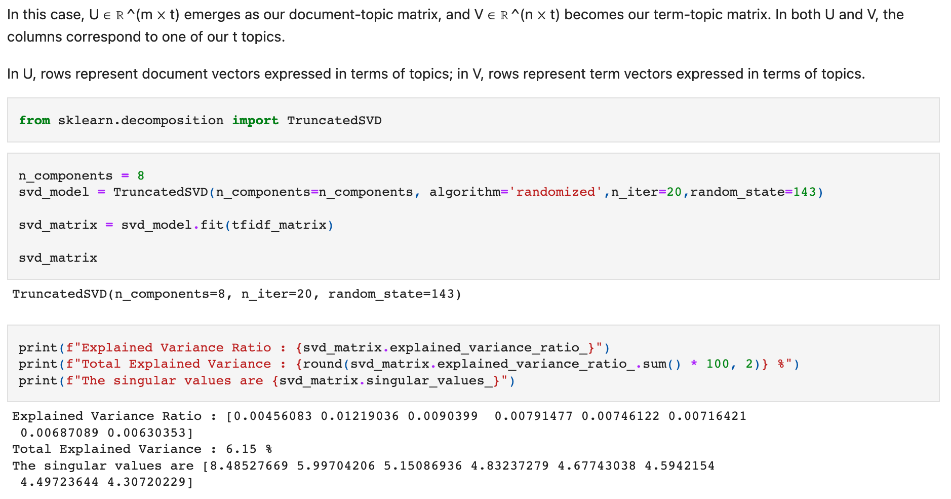

*Fig 9.4.2.1 Truncated SVD Algorithm*

## ML Models:

### Logistic Regression

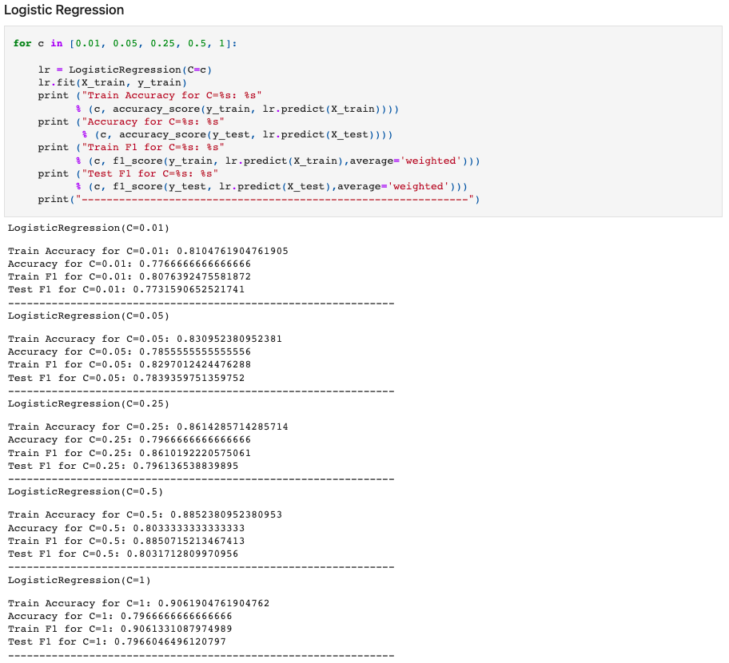

*Fig 9.4.3.1.1 Logistic Regression*

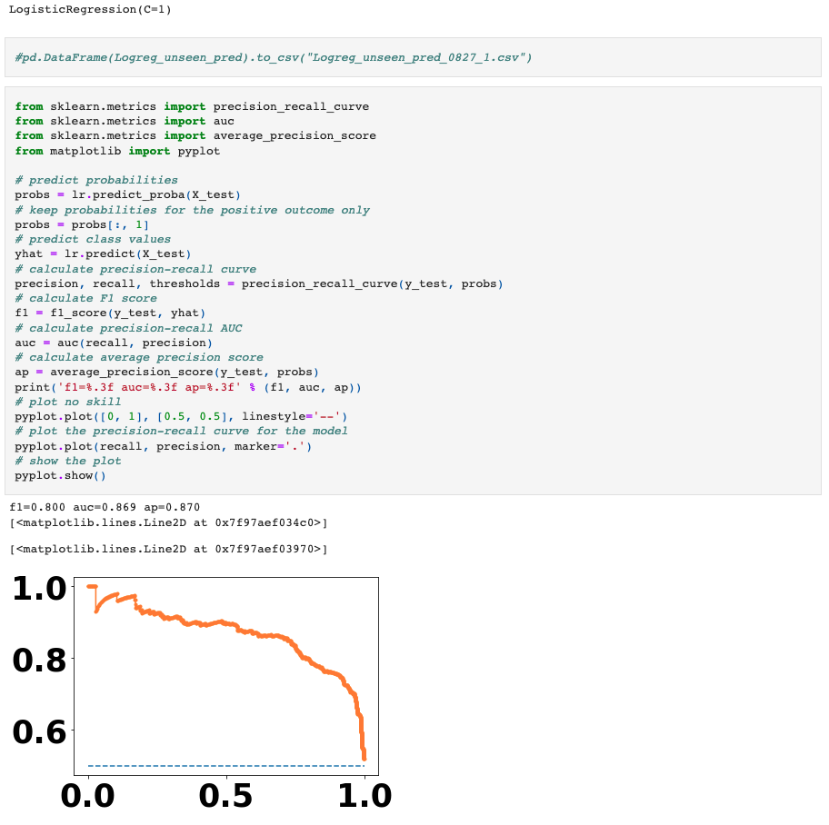

*Fig 9.4.3.1.2 AUC Curve of Logistic Regression*

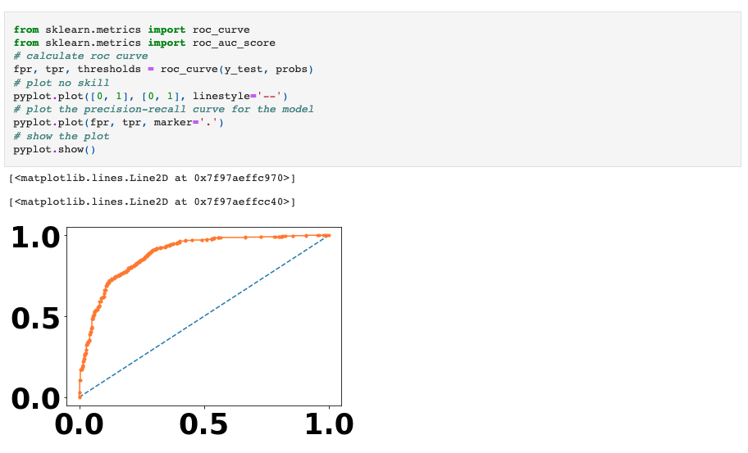

*Fig 9.4.3.1.3 Precision-Recall Curve of Logistic Regression*

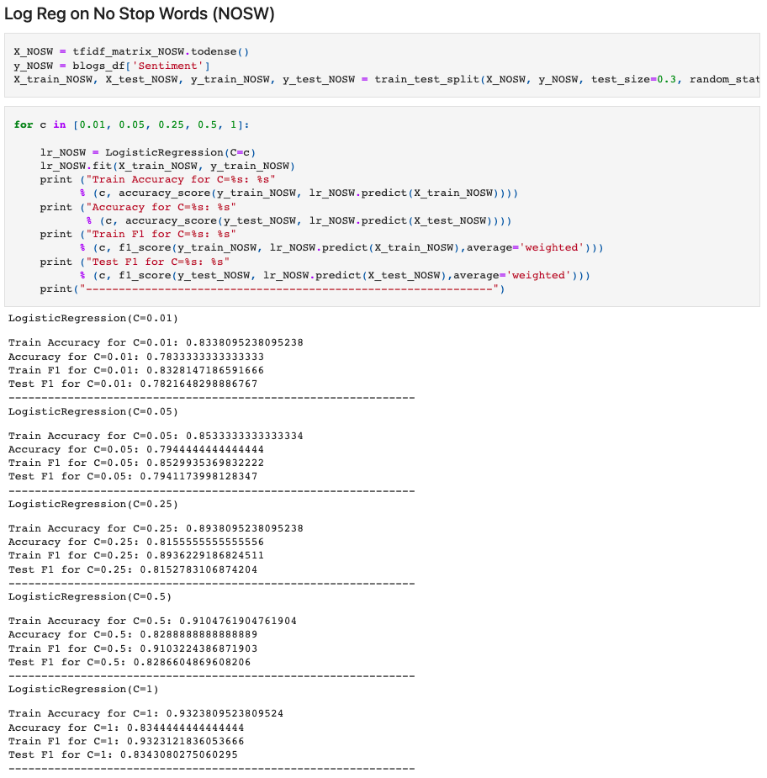

*Fig 9.4.3.1.3 Applying Logistic Regression on data with no stop words*

### Linear SVC

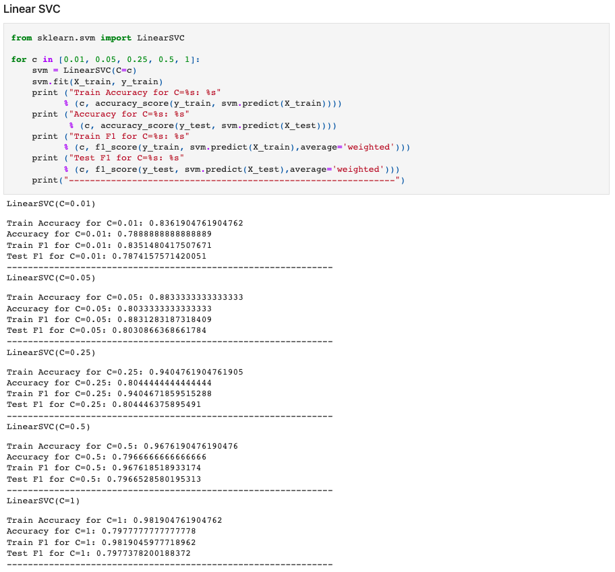

*Fig 9.4.3.2.1 Linear SVC Algorithm*

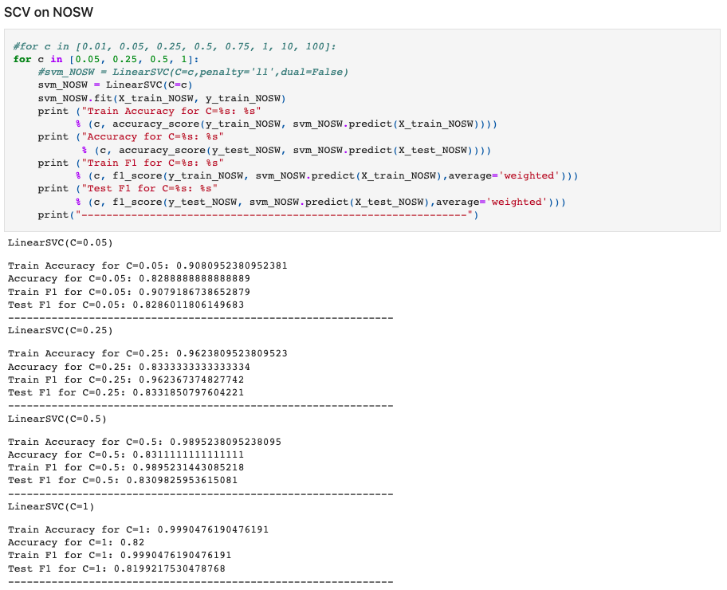

*Fig 9.4.3.2.2 Linear SVC Algorithm on no stop words data*

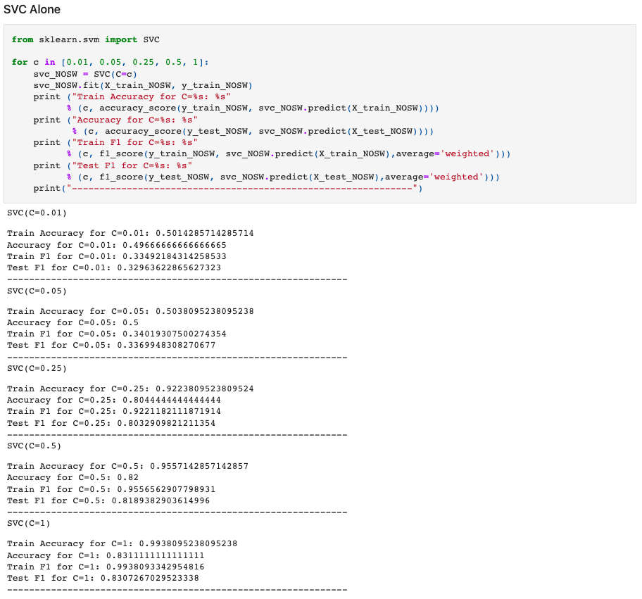

*Fig 9.4.3.2.2 SVC Algorithm on no stop words data*

### Random Forest Classifier

### XGBoost

(Both Random Forest, XGBoost are combined in one screenshot)

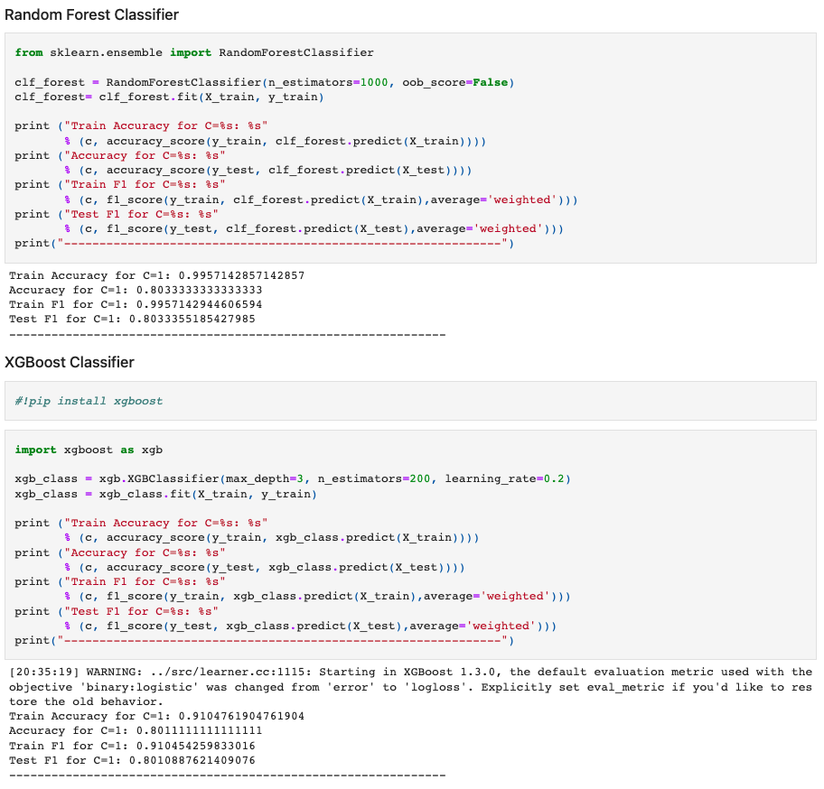

*Fig 9.4.3.4.1 Code chunk showing the application of Random Forest classifier and XGBoost Classifier*

## Building Deep Learning Models:

### LSTM Model

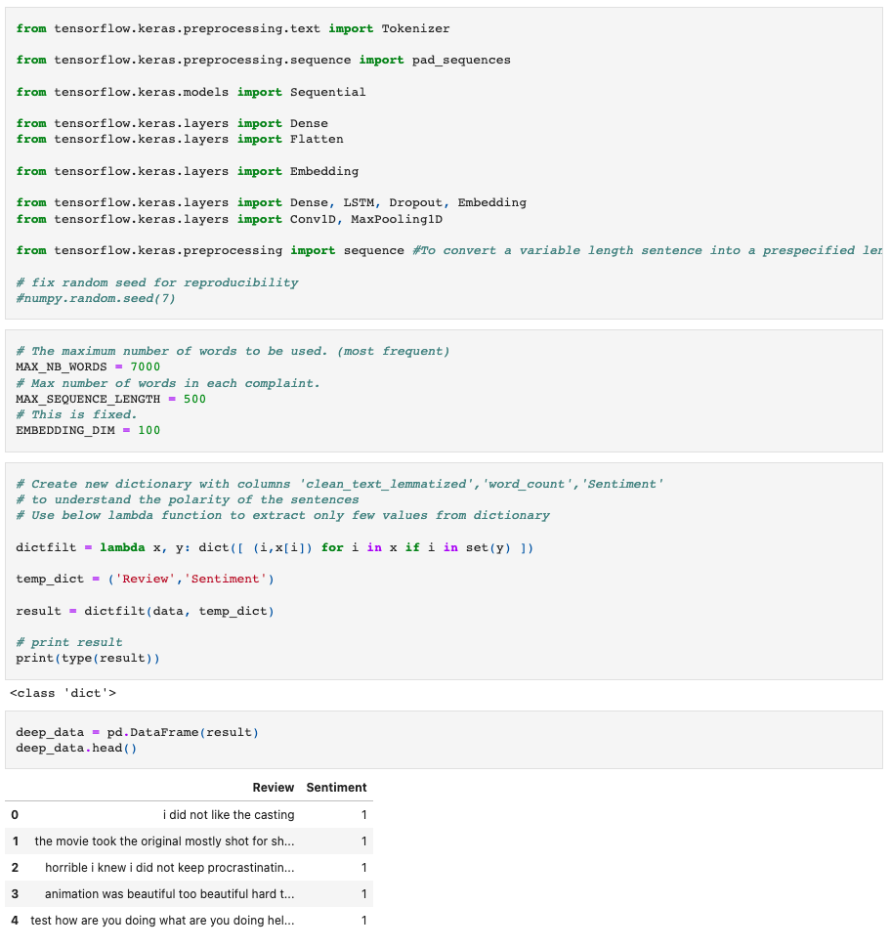

*Fig 9.4.4.1.1 Application of LSTM Algorithm – import of libraries, setting up hyperparameters*

Model building:

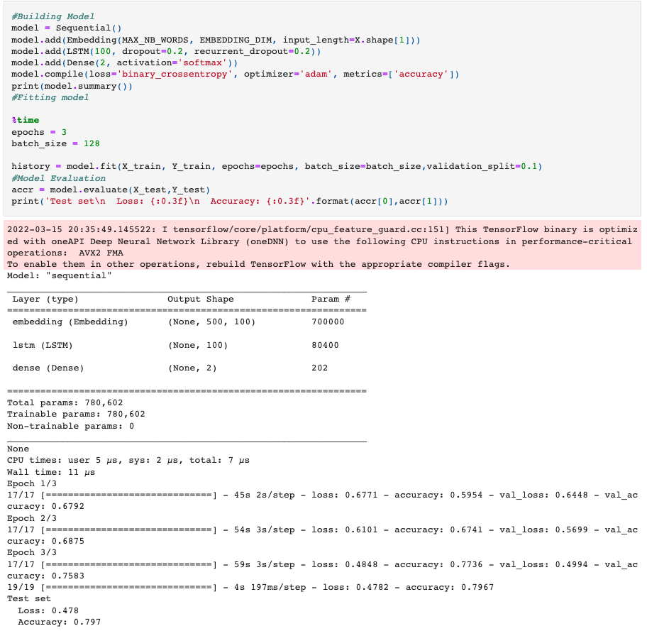

*Fig 9.4.4.1.2 Application of LSTM Algorithm – Model, running, and output*

Plotting loss and Accuracy:

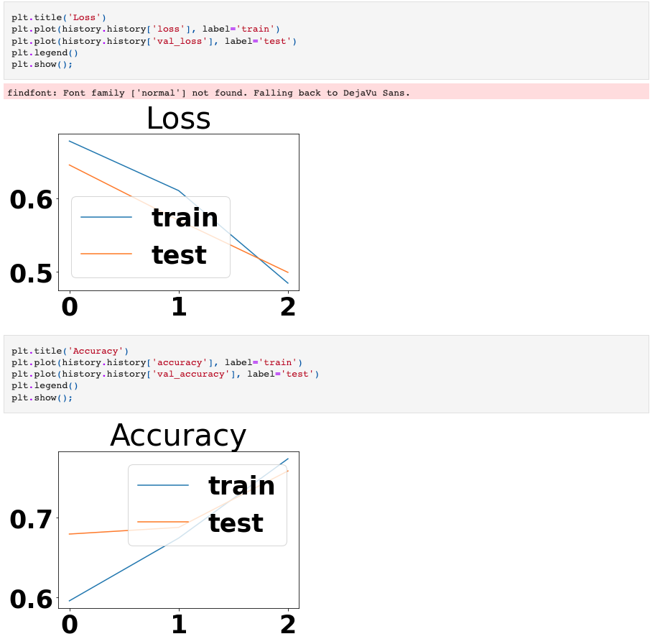

*Fig 9.4.4.1.3 Application of LSTM Algorithm – Loss and Accuracy curves of LSTM Model.*

### LSTM + CNN

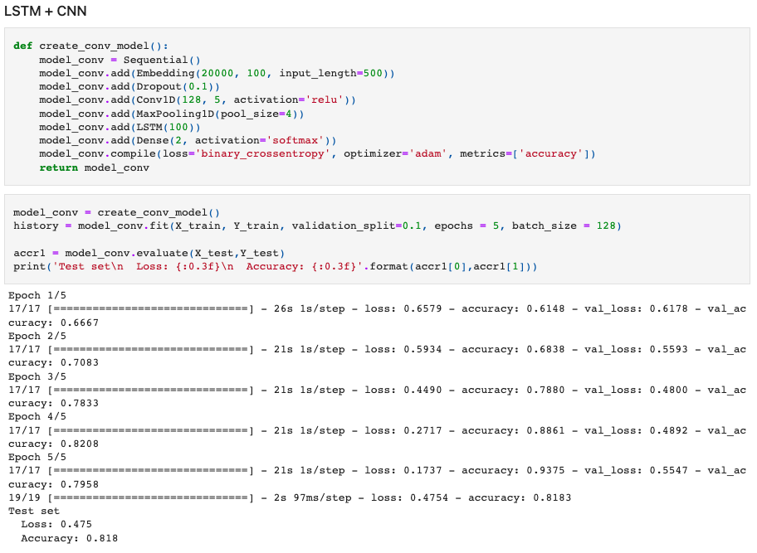

*Fig 9.4.4.2.1 Application of LSTM+CNN Algorithm – import of libraries, setting up hyperparameters*

# BERT Model

# EDA & Pre Processing

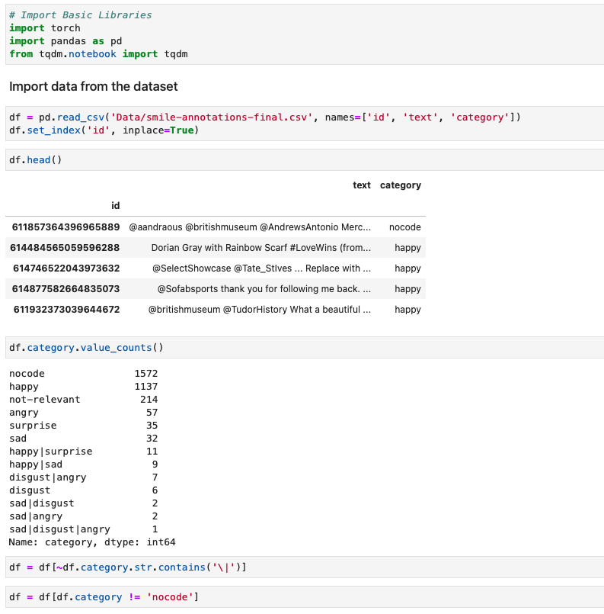

*Fig 9.5.1.1 BERT Model – Import of data, Pre Processing, dropping of columns*

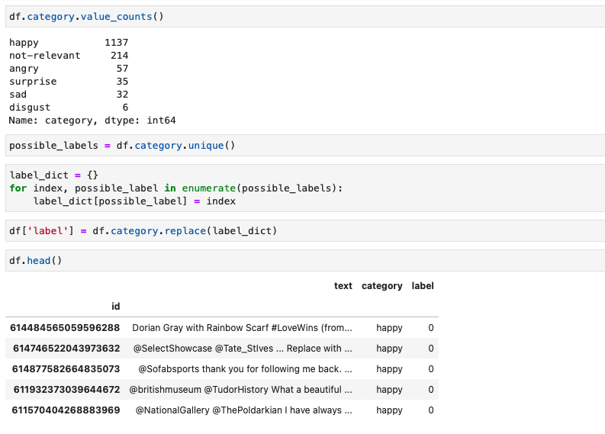

*Fig 9.5.1.1 BERT Model – EDA on the data*

# Training/Validation Split

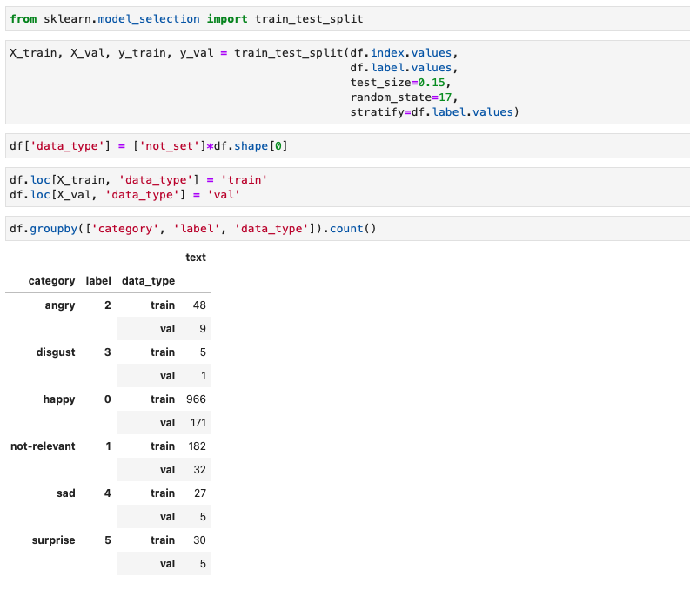

*Fig 9.5.2.1 Code chunk showing Training/Validation Split*

# Tokenization and Encoding of the Data

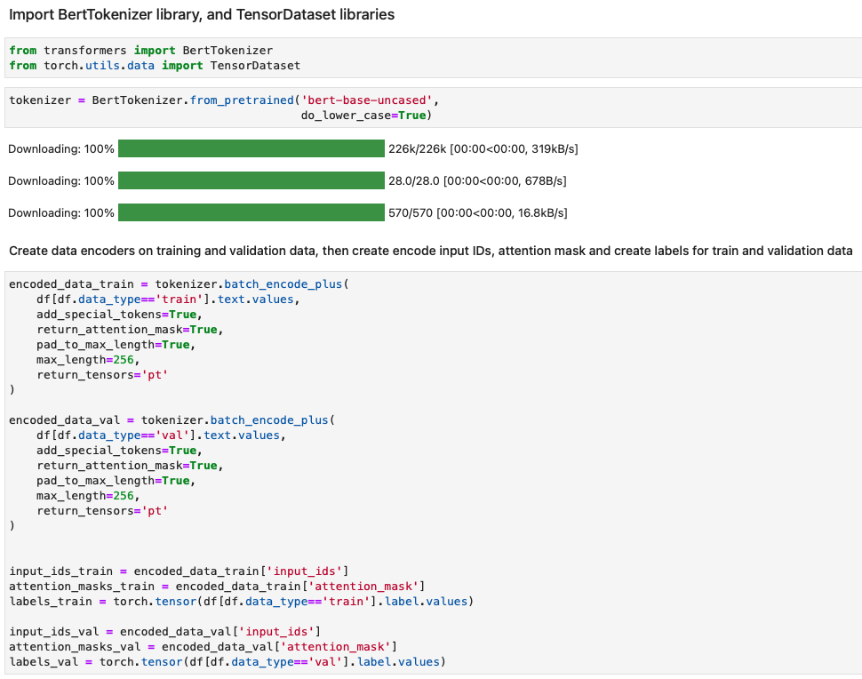

*Fig 9.5.3.1 Tokenization, creation of data encoders*

# Setup BERT Pretrained Model

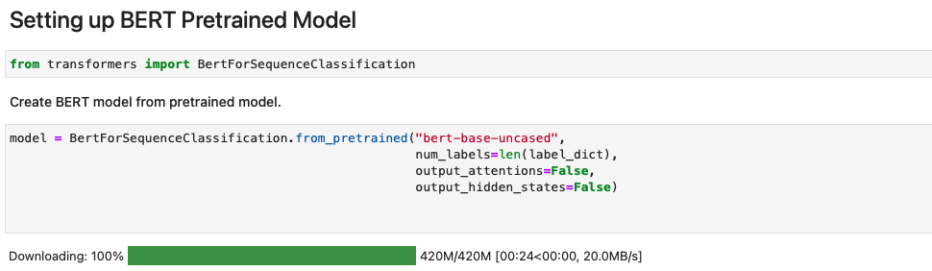

*Fig 9.5.4.1 Setup of BERT pretrained model*

# Create Data Loaders

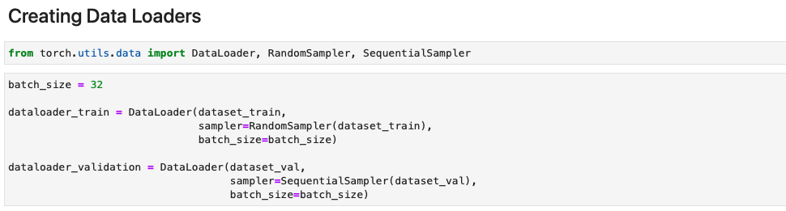

*Fig 9.5.5.1 Code chunk showing the creation of data loaders.*

# Setup Optimizer and Scheduler

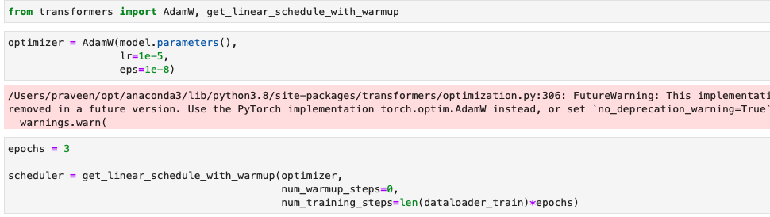

*Fig 9.5.6.1 Code chunk showing the setup of optimizer and scheduler*

# Defining Performance Metrics

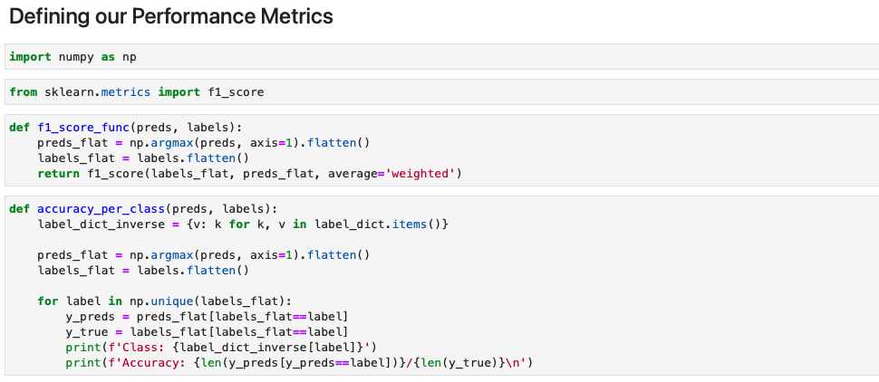

*Fig 9.5.7.1 Code defining performance metrics like F1 Score, Accuracy*

# Create Training Loop

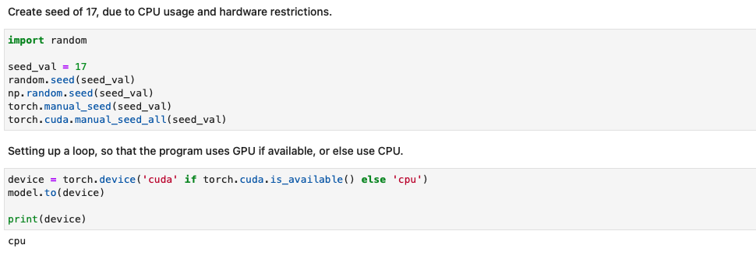

*Fig 9.5.8.1 Code showing setting up of seed and creation of training loop*

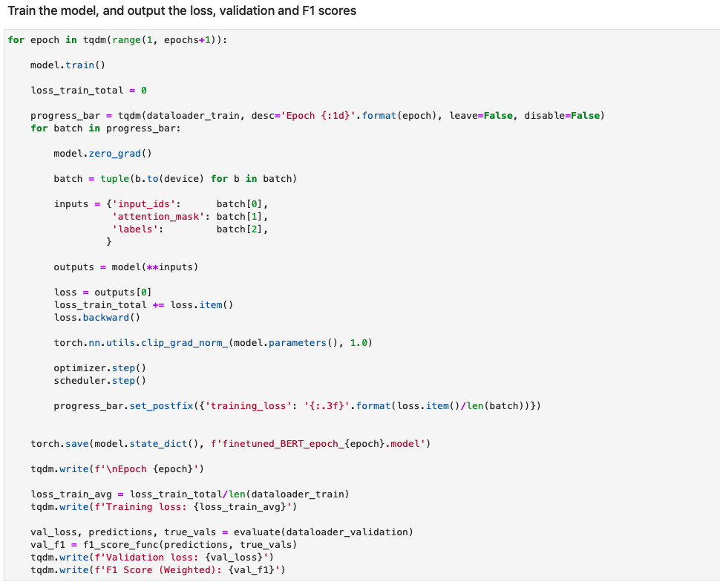

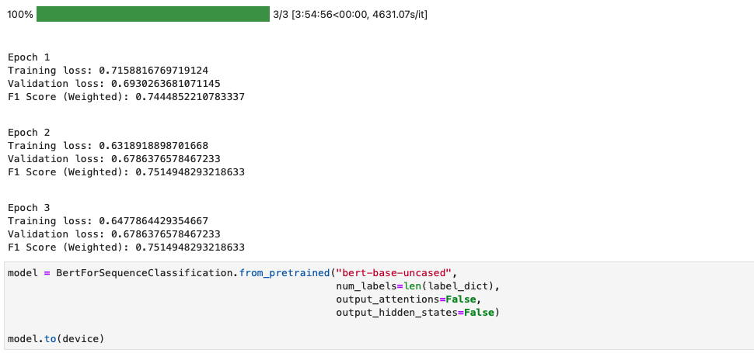

*Fig 9.5.8.2 Code showing BERT model application, predictions*

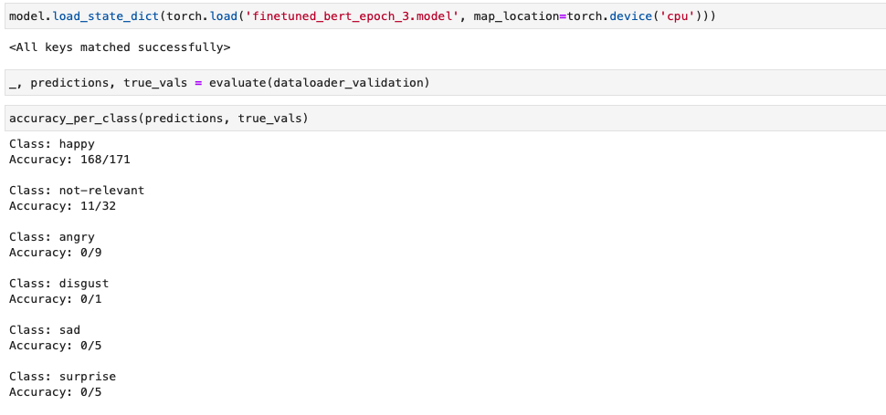

*Fig 9.5.8.3 Code showing prediction accuracy*

# Particulars of the Supervisor and Examiner

|  |  |  |
| --- | --- | --- |
|  | **Supervisor** | **Additional Examiner** |
| Name | Chella Pandian | Seshagiri Rao Bhamidipati |
| Qualification | Master of Computer Application | Master of Computer Application |
| Designation | Senior Consultant | Director |
| Employing Organization and Location | ImpleVista IT India Pvt Ltd, Bengaluru | ImpleVista IT India Pvt Ltd, Bengaluru |
| Phone No.(with STD Code) | +4531333359 | +91 9008624411 |
| Email Address | [chella.pandian@implevista.com](mailto:chella.pandian@implevista.com) | seshagiri.rao@implevista.com |

**BIRLA INSTITUTE OF TECHNOLOGY & SCIENCE, PILANI**

**WORK INTEGRATED LEARNING PROGRAMMES (WILP) DIVISION**

**SECOND SEMESTER OF ACADEMIC YEAR 2021-2022**

**S2-21_MBAZG622T: Reputation Management Using Text Analytics OUTLINE**

|  |  |
| --- | --- |
| **STUDENT ID No.** | 2020MB21133 |
| **NAME OF THE STUDENT** | V Ratna Praveen Nandula |
| **STUDENT'S EMAIL ADDRESS** | praveen.nandula@implevista.com |
| **STUDENT’S EMPLOYING ORGANIZATION & LOCATION** | ImpleVista IT India Pvt Ltd, Bengaluru |
| **SUPERVISOR’S NAME** | Chella Pandian |
| **SUPERVISOR’S EMPLOYING ORGANIZATION & LOCATION** | ImpleVista IT India Pvt Ltd, Bengaluru |
| **SUPERVISOR’S EMAIL ADDRESS** | [chella.pandian@implevista.com](mailto:chella.pandian@implevista.com) |
| **ADDITIONAL EXAMINAER’S NAME** | Seshagiri Rao Bhamidipati |
| **ADDITIONAL EXAMINER’S EMPLOYING ORGANIZATION & LOCATION** | ImpleVista IT India Pvt Ltd, Bengaluru |
| **ADDITIONAL EXAMINER’S EMAIL ADDRESS** | seshagiri.rao@implevista.com |
| **DISSERTATION / PROJECT / PROJECT WORK TITLE** | Reputation Management Using Text Analytics |

|  |  |  |
| --- | --- | --- |
|  |  |  |
| **Signature of Student** | **Signature of Supervisor** | **Signature of Additional Examiner** |
| **Name: V Ratna Praveen Nandula** | **Name: Chella Pandian** | **Name: Seshagiri Rao Bhamidipati** |